ME1000 RF Circuit Design
Lab 5
Mixer Characterization Using
Vector Network Analyzer
This courseware product contains scholarly and technical information and is protected by copyright laws and international treaties. No part of this publication may be reproduced by any means, be it transmitted, transcribed, photocopied, stored in a retrieval system, or translated into any language in any form, without the prior written permission of Acehub Vista Sdn. Bhd.

The use of the courseware product and all other products developed and/or distributed by Acehub Vista Sdn. Bhd. are subject to the applicable License Agreement.

For further information, see the Courseware Product License Agreement.

Objective
- To measure the SWR, return loss, RF feedthrough, and local oscillator (LO) isolations of a mixer with a vector network analyzer (VNA)

Equipment Required
- Keysight E5061A ENA-L RF Network Analyzer
- ME1000 RF Transceiver Kit (Receiver Unit)

Accessories Required
- TRM standard calibration kit with matched load (50 Ω)
- 2 × SMA(m)-to-SMA(m) coaxial cable
- 1 × USB cable
- A PC running Microsoft® Windows® XP/Vista, pre-installed with the RF Trainer Control Panel software

IMPORTANT:
Turn off the training kit when not in use. The kit will turn off automatically when no mouse or keyboard action is detected for more than 10 minutes. Always ensure that the casing is grounded and the cover is latched up before powering up the device.

Introduction

Basic Equipment Setup
Figure 1 – General Equipment Configuration for Mixer Measurement Using a VNA

Important:
For this laboratory, you have to recall the calibration data from Lab 1 by pressing <Save/Recall> on the VNA. Using the knob, select the saved calibration data in the nonvolatile memory and press RECALL STATE.
It is best to look at just one channel at a time. That is, when you are looking at transmission measurements, turn Ch 1 off, and when you are doing reflection measurements, turn Ch 2 off. When viewing signals, use the <Scale>, <Format>, and <Marker> menus to help you navigate with ease. Use the AUTO SCALE option under the <Scale> menu, to help you manipulate the display.

Note that if you press <Preset>, you will need to recall your calibration. You can verify your calibration at anytime with a TRM short PCB board for reflection and a TRM through PCB board for transmission. Similarly, the above calibration can be performed using appropriate cal standards. (Preset also sets the “Calibration Kit” selection to the default kit that generally does not correspond to the TRM PCB board you will use.)

Note:
Use the marker to record down your readings. Marker(s) is/are used to obtain a reading at a particular frequency or amplitude. For simplicity, you may wish to use the Marker Function or Marker Search option to look for maximum and minimum points.

RF/IF Port SWR Measurement with a VNA
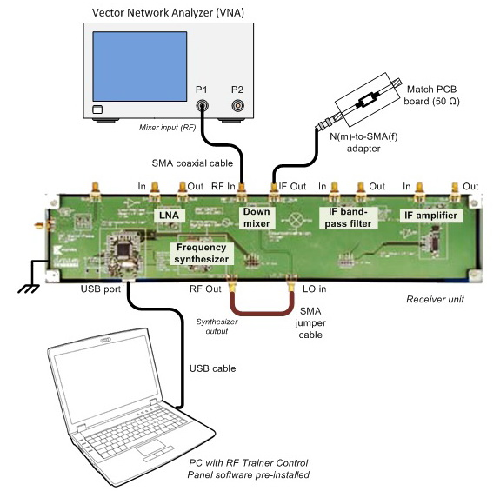
Figure 2 – RF Port SWR Measurement with a VNA Setup
Make the connection as shown in Figure 2 to determine the RF port SWR. Note that you must connect the synthesizer output into the LO port of the mixer via a SMA jumper cable. Also, terminate the IF port with the 50 Ω matched PCB board. Port 2 of the VNA is not used.
- Recall the TRM calibration data (saved in the previous lab) from the nonvolatile memory.
- On your PC, launch the RF Trainer Control Panel. Select the RX Unit from the board selection and click Connect to RF Trainer. In the RX Unit Control area, click the Mixer Off/On to power up the mixer. You will see the mixer PCB LED light up on the trainer when it is powered on. Next, under the Frequency Synthesizer Control area, click Frequency Synthesizer Off/On to power up the synthesizer. You will see the frequency synthesizer PCB LED light up on the trainer when it is powered on. Set the frequency to 818 MHz.
- Use the following settings to determine the SWR of the RF port:
Start: 700 MHz
Stop: 900 MHz
Format: SWR
Measure: S11
Scale: Auto scale

E5061A setting: “[ ]”: Hardkey; “{ }”: Softkey
Start frequency: [Start] > [700] > [M/μ]
Stop frequency: [Stop] > [900] > [M/μ]
Format: [Format] > {SWR}
Measure: [Meas] > {S11}
Scale: [Scale] > {Auto Scale}

Exercises
- What is the standing wave ratio at 868 MHz?
SWR @868 MHz = 1:__________

- Change the setting to display the log magnitude.
Format: Log magnitude

E5061A setting: “[ ]”: Hardkey; “{ }”: Softkey
Format: [Format] > {Log Mag}
Scale: [Scale] > {Auto Scale}

Exercises
- What is the input return loss at 868 MHz?
Input return loss @868 MHz = __________ dB

- Plot the input return loss from 700 MHz to 900 MHz.
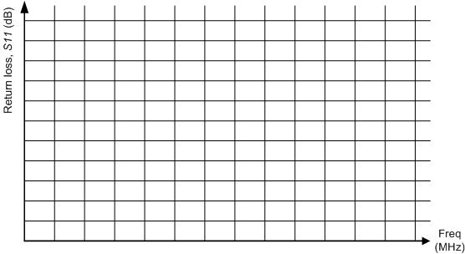

- Connect the IF port to port 1 of the VNA and terminate the RF port with the matched load. Change the start and stop frequencies to 10 MHz and 100 MHz respectively. Make sure that you have turned off the mixer DC supply before removing any connections by clicking Mixer Off/On in the RF Trainer Control Panel software. Power on the mixer again when the proper connection has been made.
Start: 10 MHz
Stop: 100 MHz
Format: SWR
Scale: Auto scale

E5061A setting: “[ ]”: Hardkey; “{ }”: Softkey
Start frequency: [Start] > [10] > [M/μ]
Stop frequency: [Stop] > [100] > [M/μ]
Format: [Format] > {SWR}
Scale: [Scale] > {Auto Scale}

Exercises
- What is the standing wave ratio at 50 MHz?
SWR @50 MHz = 1: __________

- Change the setting to display the log magnitude.
Format: Log magnitude

E5061A setting: “[ ]”: Hardkey; “{ }”: Softkey
Format: [Format] > {Log Mag}
Scale: [Scale] > {Auto Scale}

Exercises
- What is the input return loss at 50 MHz?
Input return loss @50 MHz = __________ dB
- Plot the input return loss from 10 MHz to 100 MHz.

LO Port SWR Measurement with a VNA
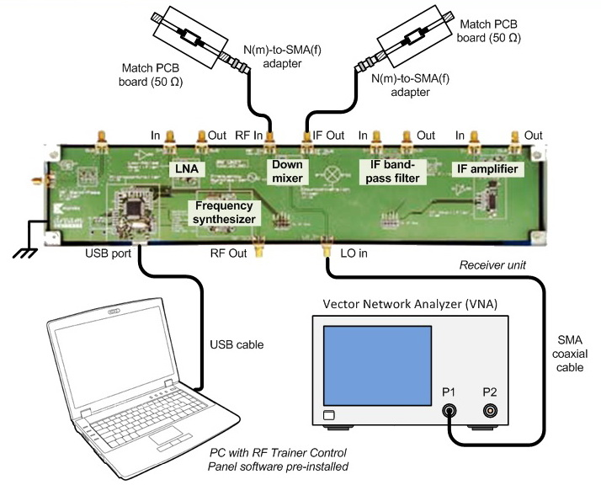
Figure 3 – LO Port SWR Measurement with a VNA Setup
Make the connection as shown in Figure 3 to determine the LO port SWR. Note that you need to terminate both the IF and RF ports with a 50 Ω matched PCB board. Port 2 of the VNA and frequency synthesizer are not used in this measurement.
- On your PC, launch the RF Trainer Control Panel. Click Connect to RF Trainer. In the RX Unit Control area, click Mixer Off/On to power up the mixer. You will see the mixer PCB LED light up on the trainer when it is powered on.

- Use the following settings to determine the SWR of the RF port:
Start: 700 MHz
Stop: 900 MHz
Format: SWR
Measure: S11
Scale: Auto scale

E5061A setting: “[ ]”: Hardkey; “{ }”: Softkey
Start frequency: [Start] > [700] > [M/μ]
Stop frequency: [Stop] > [900] > [M/μ]
Format: [Format] > {SWR}
Measure: [Meas] > {S11}
Scale: [Scale] > {Auto Scale}

Exercises
- What is the standing wave ratio at 818 MHz?
SWR @818 MHz = 1:__________
- Change the setting to display the log magnitude plot.
Format: Log magnitude

E5061A setting: “[ ]”: Hardkey; “{ }”: Softkey
Format: [Format] > {Log Mag}
Scale: [Scale] > {Auto Scale}

Exercises
- What is the input return loss at 818 MHz?

Input return loss @818 MHz = __________ dB

- Plot the input return loss from 700 MHz to 900 MHz.

RF Feedthrough Measurement
Make the connection as shown in Figure 1 to determine the RF feedthrough. Note that you must connect the synthesizer output into the LO port of the mixer via a SMA jumper cable. Also, connect both the RF and IF ports to port 1 and port 2 of the VNA.
- On your PC, launch the RF Trainer Control Panel. Click Connect to RF Trainer. In the RX Unit Control area, click Mixer Off/On to power up the mixer. You will see the mixer PCB LED light up on the trainer when it is powered on. Next, under the Frequency Synthesizer Control area, adjust the frequency to 818 MHz. This is the LO frequency input into the mixer.
- Use the following settings:
Start: 700 MHz
Stop: 900 MHz
Format: Log magnitude
Measure: S21
Scale: Auto scale

E5061A setting: “[ ]”: Hardkey; “{ }”: Softkey
Start frequency: [Start] > [700] > [M/μ]
Stop frequency: [Stop] > [900] > [M/μ]
Format: [Format] > {Log Mag}
Measure: [Meas] > {S21}
Scale: [Scale] > {Auto Scale}

Exercises
- Find the RF feedthrough at 868 MHz.
RF feedthrough @868 MHz = __________ dB

- Plot the RF feedthrough from an input frequency of 700 MHz to 900 MHz.

LO-to-RF Isolation Measurement
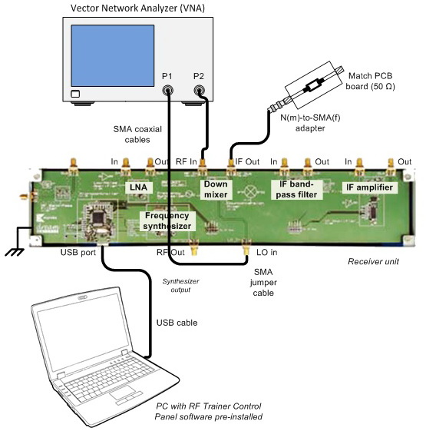
Figure 4 – LO-to-RF Isolation Measurement with a VNA Setup
Make the connection as shown in Figure 4 to determine the LO-to-RF isolation. Connect both the LO and RF ports to port 1 and port 2 of the VNA respectively. The IF port is terminated with a 50-Ω matched load.
- On your PC, launch the RF Trainer Control Panel. Click Connect to RF Trainer. In the RX Unit Control area, click Mixer Off/On to power up the mixer. You will see the mixer PCB LED light up on the trainer when it is powered on.

- Use the following settings:
Start: 700 MHz
Stop: 900 MHz
Format: Log magnitude
Measure: S21
Scale: Auto scale

E5061A setting: “[ ]”: Hardkey; “{ }”: Softkey
Start frequency: [Start] > [700] > [M/μ]
Stop frequency: [Stop] > [900] > [M/μ]
Format: [Format] > {Log Mag}
Measure: [Meas] > {S21}
Scale: [Scale] > {Auto Scale}

Exercises
- Find the LO-to-RF isolation at 818 MHz.
LO-to-RF isolation @818 MHz = __________ dB

- Plot the isolation from an input frequency of 700 MHz to 900 MHz.

LO-to-IF isolation measurement
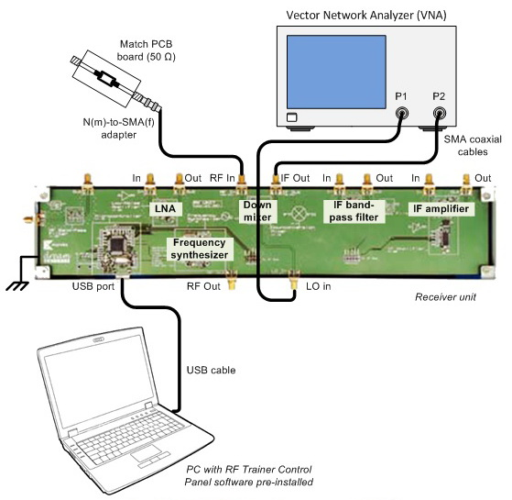
Figure 5 – LO-to-IF Isolation Measurement with a VNA
Make the connection as shown in Figure 5 to determine the LO-to-IF isolation. Connect both the LO and IF ports to port 1 and port 2 of the VNA respectively. The RF port is terminated with a 50 Ω matched load.
- On your PC, launch the RF Trainer Control Panel. Click Connect to RF Trainer. In the RX Unit Control area, click Mixer Off/On to power up the mixer. You will see the mixer PCB LED light up on the trainer when it is powered on.
- Use the following settings:
Start: 700 MHz
Stop: 900 MHz
Format: Log magnitude
Measure: S21
Scale: Auto scale

E5061A setting: “[ ]”: Hardkey; “{ }”: Softkey
Start frequency: [Start] > [700] > [M/μ]
Stop frequency: [Stop] > [900] > [M/μ]
Format: [Format] > {Log Mag}
Measure: [Meas] > {S21}
Scale: [Scale] > {Auto Scale}

Exercises
- Find the LO-to-IF isolation at 818 MHz.
LO-to-IF isolation @818 MHz = __________ dB

- Plot the isolation from an input frequency of 700 MHz to 900 MHz.

References
- Application Note 1287-1, “Understanding the Fundamental Principles of Vector Network Analysis,” Keysight Technologies
- Application Note 1287-2, “Exploring the Architectures of Network Analyzers,” Keysight Technologies
- Product Note 8753-2, “RF Component Measurements: Mixer Measurements Using the Keysight 8753B Network Analyzer,” Keysight Technologies
- Thomas H. Lee, “Planar Microwave Engineering,” Cambridge University Press, 2004

