ME1000 RF Circuit Design
Lab 3
Low-Noise Amplifier Characterization Using
Vector Network Analyzer
This courseware product contains scholarly and technical information and is protected by copyright laws and international treaties. No part of this publication may be reproduced by any means, be it transmitted, transcribed, photocopied, stored in a retrieval system, or translated into any language in any form, without the prior written permission of Acehub Vista Sdn. Bhd.

The use of the courseware product and all other products developed and/or distributed by Acehub Vista Sdn. Bhd. are subject to the applicable License Agreement.

For further information, see the Courseware Product License Agreement.

Objective
- To characterize the low-noise amplifier (LNA) with reflection and transmission measurement via a vector network analyzer (VNA)

Equipment Required
- Keysight E5061A ENA-L RF Network Analyzer
- ME1000 RF Transceiver Kit (Receiver Unit)

Accessories Required
- 2 × SMA(m)-to-SMA(m) coaxial cable
- 1 × USB cable
- A PC running Microsoft® Windows XP/Vista®, pre-installed with the RF Trainer Control Panel software

IMPORTANT:
Turn off the training kit when not in use. The kit will turn off automatically when no mouse or keyboard action is detected for more than 10 minutes. Always ensure that the casing is grounded and the cover is latched up before powering up the device.

Introduction

Basic Equipment Setup
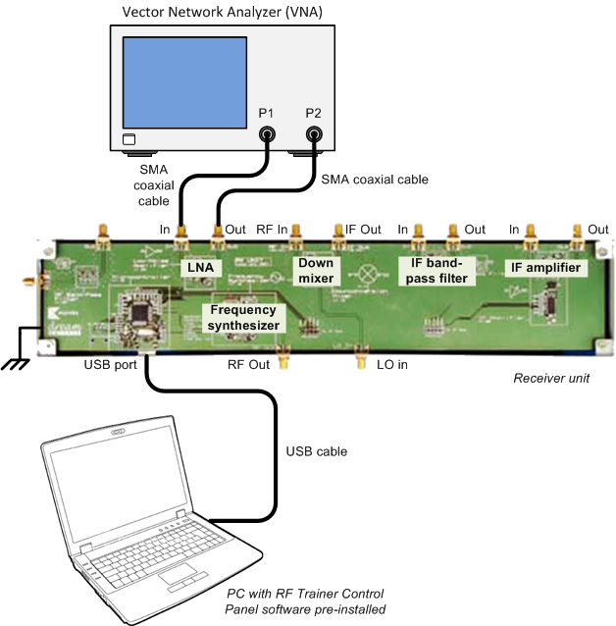
Figure 1 – General Equipment Configuration for LNA Measurement Using a VNA

Important:
In measuring a high gain amplifier, it is possible to overload the amplifier input. This will cause the unit to saturate and cause a significant non-linearity in the output signal, which will possibly damage the unit. It can also damage the test equipment due to the high power amplification. You should either add more attenuation to the input or output of the amplifier or reduce the RF power of the signal source before repeating the measurement.
For this laboratory, you have to recall the calibration data from Lab 1 by pressing <Save/Recall> on the VNA. Using the knob, select the saved calibration data in the nonvolatile memory and press RECALL STATE.
It is best to look at just one channel at a time. That is, when you are looking at transmission measurements, turn Ch 1 off, and when you are doing reflection measurements, turn Ch 2 off. When viewing signals, use the <Scale>, <Format>, and <Marker> menus to help you navigate with ease. Use the AUTO SCALE option under the <Scale> menu, to help you manipulate the display.
Note that if you press <Preset>, you will need to recall your calibration. You can verify your calibration at anytime with a TRM short PCB board for reflection and a TRM through PCB board for transmission. Similarly, the above calibration can be performed using appropriate cal standards. (Preset also sets the “Calibration Kit” selection to the default kit that generally does not correspond to the TRM PCB board you will use.)

Note:
Use the marker to record down your readings. Marker(s) is/are used to obtain a reading at a particular frequency or amplitude. For simplicity, you may wish to use the Marker Function or Marker Search option to look for maximum and minimum points.

Transmission Measurements
- Recall the calibration data (saved from the previous lab) from the nonvolatile memory.
- Connect the LNA as shown in Figure 1.
- Set the following settings to reduce the input source power to the LNA:
Power: Source power, –40 dBm

E5061A setting: “[ ]”: Hardkey; “{ }”: Softkey
Source power: [Sweep Setup] > {Power} > {Power} > [± 40] > [x1]

- On your PC, launch the RF Trainer Control Panel. Select the RX Unit from the board selection and click Connect to RF Trainer. In the RX Unit Control area, click LNA Off/On to power up the LNA. You will see the LNA PCB LED light up on the trainer when it is powered on.
- Use the following settings to determine the small signal gain of the LNA for a frequency range of between 700 MHz and 1 GHz:
Start: 700 MHz
Stop: 1 GHz
Format: Log magnitude
Measure: S21
Scale: Auto scale

E5061A setting: “[ ]”: Hardkey; “{ }”: Softkey
Start frequency: [Start] > [700] > [M/μ]
Stop frequency: [Stop] > [1] > [G/n]
Format: [Format] > {Log Mag}
Measure: [Meas] > {S21}
Scale: [Scale] > {Auto Scale}

Exercises
- Find the maximum gain and the frequency at which it occurs.
Gmax = __________ dB at __________ MHz
- Find the frequency below this at which the gain is reduced by 3 dB from the maximum gain.
Gmax – 3 dB occurs at __________ MHz
- Find the gain at 868 MHz.
Gain @868 MHz = __________ dB
- Find the gain flatness.
Gain flatness = ± __________ dB
- Change the following settings to display the phase of the LNA:
Format: Phase
Scale: Auto scale

E5061A setting: “[ ]”: Hardkey; “{ }”: Softkey
Format: [Format] > {Phase}
Scale: [Scale] > {Auto Scale}

Exercises
- Display the phase response. How does the general shape of the phase response compare to transmission phase measured in filter characterization?
- Change the following settings to determine the group delay of the LNA:
Format: Delay
Scale: Auto scale
Averaging: Averaging on
Smoothing on
Smoothing aperture (10%)

E5061A setting: “[ ]”: Hardkey; “{ }”: Softkey
Format: [Format] > {Group Delay}
Scale: [Scale] > {Auto Scale}
Averaging: [Avg] > {Averaging ON}
Smoothing: {Smoothing ON}
Smoothing aperture: {Smoothing Aperture} > [10] > [x 1]

Exercises
- Find the group delay at 868 MHz.
Group delay @868 MHz = __________
- Is the group delay constant across 700 MHz to 1 GHz?
- How would you specify this LNA in terms of group delay across 700 MHz to 1 GHz?
Group delay from 700 MHz to 1 GHz = (__________ ± __________) ns

- Change the following settings to determine the isolation of the LNA:
Format: Log magnitude
Measure: S12
Scale: Auto scale

E5061A setting: “[ ]”: Hardkey; “{ }”: Softkey
Format: [Format] > {Group Delay}
Scale: [Scale] > {Auto Scale}
Averaging: [Avg] > {Averaging ON}
Smoothing: {Smoothing ON}
Smoothing aperture: {Smoothing Aperture} > [10] > [x 1]

Exercises
- Find the isolation at 868 MHz.
Isolation @ 868 MHz = __________ dB

Note:
Use averaging, smoothing, and smoothing aperture if necessary.

- Elaborate the importance of isolation in an amplifier.

Reflection Measurements
- Use the following settings to determine the input return loss of the LNA:
Format: Log magnitude
Measure: S11
Scale: Auto scale

E5061A setting: “[ ]”: Hardkey; “{ }”: Softkey
Format: [Format] > {Log Mag}
Measure: [Meas] > {S11}
Scale: [Scale] > {Auto Scale}

Exercises
- Find the minimum input return loss, and the frequency at which it occurs.
Minimum return loss = __________ dB at __________ MHz
- Find the maximum input return loss, and the frequency at which it occurs.

Maximum return loss = __________ dB at __________ MHz
- Find the input return loss at the frequency of 868 MHz.
Return loss @ 868 MHz = __________ dB

Note:
Use the marker function to search for the maximum and minimum values.

- Change the settings to display the SWR.
Format: SWR

E5061A setting: “[ ]”: Hardkey; “{ }”: Softkey
Format: [Format] > {SWR}

Exercises
- What is the standing wave ratio at 868 MHz?
SWR @868 MHz = 1: __________
- Change the settings to display the Smith Chart for input impedance measurement.
Format: Smith Chart

E5061A setting: “[ ]”: Hardkey; “{ }”: Softkey
Format: [Format] > {Smith} > {R+jX}

Exercises
- What is the input impedance at 868 MHz?
Input impedance @868 MHz = (__________ + j __________) Ω
- What is the equivalent inductance (H) or capacitance (F) of the reactance?
Equivalent inductance = __________ H
Equivalent capacitance = __________ F

- Explain the matching condition at the input.

- Use the following settings to determine the output return loss of the LNA:
Format: Log magnitude
Measure: S22
Scale: Auto scale

E5061A setting: “[ ]”: Hardkey; “{ }”: Softkey
Format: [Format] > {Log Mag}
Measure: [Meas] > {S22}
Scale: [Scale] > {Auto Scale}

Exercises
- Find the minimum output return loss and the frequency at which it occurs.
Minimum return loss = __________ dB at __________ MHz
- Find the maximum output return loss and the frequency at which it occurs.
Maximum return loss = __________ dB at __________ MHz
- Find the output return loss at 868 MHz.
Return loss @868 MHz = __________ dB
Note:
Use the marker function to search for the maximum and minimum values.
- Change the setting to display the SWR.
Format: SWR

E5061A setting: “[ ]”: Hardkey; “{ }”: Softkey
Format: [Format] > {SWR}

Exercises
- What is the standing wave ratio at 868 MHz?
SWR @868 MHz = 1: __________
- Change the setting to display the Smith Chart for output impedance measurement.
Format : Smith Chart

E5061A setting: “[ ]”: Hardkey; “{ }”: Softkey
Format: [Format] > {Smith} > {R+jX}

Exercises
- What is the output impedance at 868 MHz?
Output impedance @868 MHz = __________ + j __________) Ω
- What is the equivalent inductance (H) or capacitance (F) of the reactance?
Equivalent inductance = __________ H
Equivalent capacitance = __________ F

- Explain the matching condition at the output.

References
- Application Note 1287-1, “Understanding the Fundamental Principles of Vector Network Analysis,” Keysight Technologies
- Application Note 1287-2, “Exploring the Architectures of Network Analyzers,” Keysight Technologies
- Application Note 1287-3, “Applying Error Correction to Network Analyzer Measurements,” Keysight Technologies
- Application Note 1287-4, “Network Analyzer Measurements: Filter and Amplifier Examples,” Keysight Technologies
- Product Note 8753-1, “RF Component Measurements: Amplifier Measurements Using the Keysight 8753 Network Analyzer,” Keysight Technologies
- Thomas H. Lee, “Planar Microwave Engineering,” Cambridge University Press, 2004

