ME1000 RF Circuit Design
Lab 1
Calibration with Vector Network Analyzer
This courseware product contains scholarly and technical information and is protected by copyright laws and international treaties. No part of this publication may be reproduced by any means, be it transmitted, transcribed, photocopied, stored in a retrieval system, or translated into any language in any form, without the prior written permission of Acehub Vista Sdn. Bhd.

The use of the courseware product and all other products developed and/or distributed by Acehub Vista Sdn. Bhd. are subject to the applicable License Agreement.

For further information, see the Courseware Product License Agreement.

Objectives
- To modify the built-in TRM standards in the vector network analyzer (VNA)
- To perform TRM calibration using the user-defined calibration kits
- To verify the calibrated results with a Smith Chart plot

Equipment Required
- Keysight E5061A ENA-L RF Network Analyzer

Accessories Required
- TRM standard calibration kit
- 2 × SMA(m)-to-SMA(m) coaxial cable

Note:
If your VNA does not support TRM calibration, skip the TRM calibration procedure and perform the response calibration procedure outlined in the appendix.

Introduction

Basic Equipment Setup
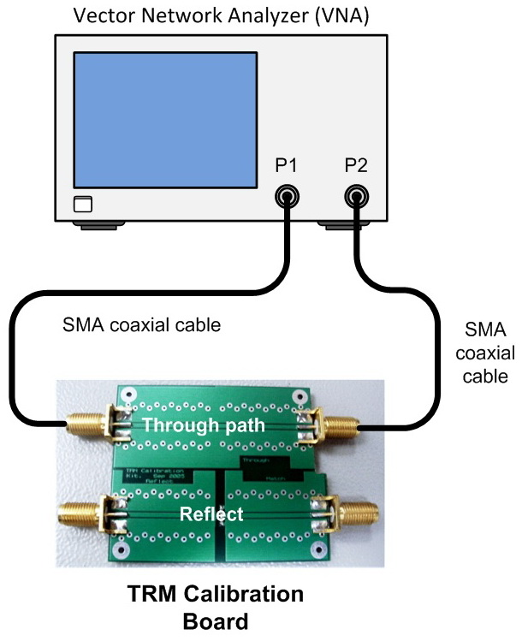
Figure 1 – General Equipment Configuration for TRM Calibration

The Need for Calibration
When measuring a device under test (DUT), you will essentially be collecting S-parameter information for a two-port network. S₁₁ relates to the reflected energy from port one, and S₂₁ relates to the energy transmitted through to port two. A VNA is also capable of measuring the phase angle of the reflected or transmitted wave that may be due to either delays or reactance. To ensure that the collected data represents the response of the DUT only — and not parts related to the cables, connectors, and the VNA itself — it is necessary to perform calibration of the equipment.
The VNA can measure the power received at the RF IN port and compare that value to the power sent at port one. However if the VNA has some frequency variation, it is necessary to measure this frequency dependent loss as that it is compensated for. This will allow the VNA to show the frequency response due to the DUT only. In addition, it is also possible for the energy to make its way from the output port to the RF IN port in some way other than through the cable. This is referred to as crosstalk, and a calibration is necessary to account for this when the dynamic range of the measurements to be taken is relatively large.
The DUT will represent a load to the VNA. To be able to judge just what type of load the DUT is, it will be necessary to connect “known” terminations. For this analyzer, the terminations are a short, an open, and a matched load. Based on these terminations, the VNA applies the data it collects to an error model. It will calculate the coefficient errors that will be applied to the raw measurement data, and disregard data that are related to the cables, connectors, or the VNA.

Thru-Reflect-Match (TRM) Calibrations
The TRM calibrations are the so-called "self-calibration" method, alternative to the traditional two-port error correction that uses short, open, load, and through standards (SOLT calibration). They offer equivalent accuracy (sometimes better), and have the advantage that fewer and simpler standards are needed. They are particularly useful for measurements of non-coaxial devices, such as fixtures and microstrip circuits. Microstrip devices in the form of chips, MMIC, packaged transistors, or beam-lead diodes cannot be connected directly to the coaxial ports of the VNA.
Compared to the SOLT calibration, the requirements on these standards are much easier to meet, so they are more easily constructed. During the calibration process, there are more measurements made of the standards than there are unknown error terms. The calibration math ends up with ten equations and eight unknowns, so there is redundant information, which can be used to calculate the propagation constant of the Line standard, and the reflection coefficient of the Reflect standard. Here are the requirements for each standard:
- The Thru standard should have zero length (so its loss and Z0 are unimportant). The shorter Line standard, which is often referred to as a non-zero length Thru standard, should have the same Z0 as the longer Line standard. Its propagation constant (delay and loss) need to be accurately specified only if it is used to set the reference planes. If you want the reference planes to be set to the middle of the non-zero length Thru standard, then you should specify its delay to be zero.
- The Reflect standard should have a high reflection coefficient, but its magnitude need not be known. The phase of its reflection coefficient must be approximately specified, to within
± 1/4 wavelength or ± 90 degrees. It is important that the same Reflect standard be used to calibrate both measurement ports. Ideally, only one Reflect standard is constructed, and it is connected first to port 1, and then to port 2.
- The Match standard is simply a load; its impedance sets the characteristic impedance of the calibrated measurements. The same load should be used on both ports. It is used in place of the Line standard at low frequencies, where 1/4 wavelength would be much too long. A broadband calibration kit may include one Match standard and several Line standards to cover the complete frequency range.
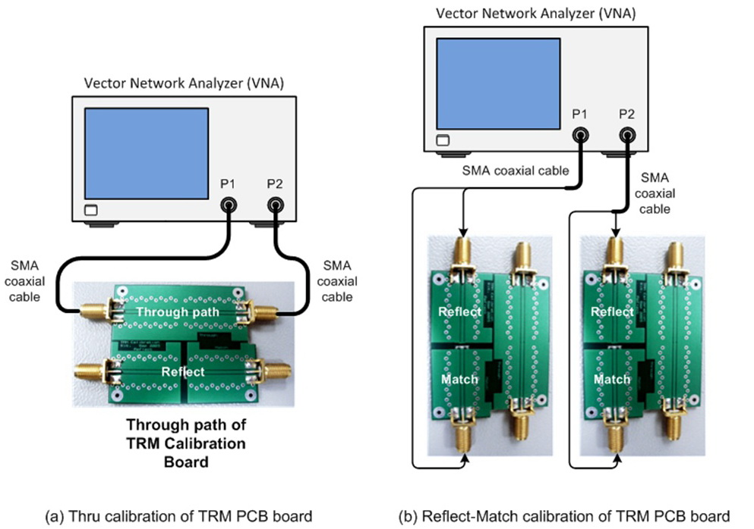
Figure 2 – Thru-Reflect-Match Calibration Setup

Calibration Procedure

Modifying the TRM Standards
To use the TRM technique, the calibration standards characteristics must be entered into the analyzer’s user-defined calibration kit.
In this procedure, you will set the TRM kit that contains the following:
- Zero length THRU
- “Flush” short for the REFLECT standard (0 second offset)
- 50 Ω termination for the MATCH (infinite length line)
Note:
The following steps are required to set up a VNA, based on Keysight 8753 Series VNA.
- Press <Preset> <Cal> and select CAL KIT > MODIFY > DEFINE STANDARD.
- To define the short standard:
Press SHORT > MODIFY STD DEFINITION > SPECIFY OFFSET > OFFSET DELAY. Enter <0> <x1> and press STD OFFSET DONE > STD DONE (DEFINED).

- To define the Thru/Line standard:
Press DEFINE STANDARD and enter <4> <x1>. Next, press DELAY/THRU > MODIFY STD DEFINITION > SPECIFY OFFSET > OFFSET DELAY. Enter <0> <x1> and press STD OFFSET DONE > STD DONE (DEFINED).

- To define the Line/Match standard:
Press DEFINE STANDARD and enter <3> <x1> and press LOAD > MODIFY STD DEFINITION > FIXED > STD DONE.

- To assign the calibration standards to the various TRM calibration classes:
Press SPECIFY CLASS > MORE > MORE > TRL REFLECT.

- Since you have previously designated standard #1 for the REFLECT standard, enter <1> <x1>.
- Since you have previously designated standard #3 for the LINE/MATCH standard, press TRL LINE OR MATCH and enter <3> <x1>.
- Since you have previously designated standard #1 for the THRU/LINE standard, press TRL THRU and enter <4> <x1>.
- To complete the specification of class assignments, press SPECIFY CLASS DONE.
- Press LABEL CLASS > MORE > MORE.
- Change the label of the TRL REFLECT class to TRMSHORT.
- Change the label of the TRL LINE OR MATCH class to TRMLOAD.
- Change the label of the TRL THRU class to TRMTHRU.
- Press LABEL CLASS DONE.
- Press LABELKIT and create a label with the name “TRMKIT1” and press DONE.
- To save the newly defined kit into the nonvolatile memory, press KIT DONE (MODIFIED) > SAVE USER KIT.

TRM Error Correction
- Press <Cal> and press CAL KIT > SELECT CAL KIT > USER KIT > RETURN > RETURN > CALIBRATE MENU > TRL*/LRM* 2-PORT.
- To measure the TRM THRU, connect the “zero length” transmission line (Thru PCB board) between port 1 and port 2, as shown in Figure 2(a). Press THRU > TRMTHRU.
- To measure the TRM SHORT, connect the short (Reflect PCB board) to port 1 (as shown in Figure 2(b), and press S11 REFL: TRMSHORT.
- Connect the short to port 2 and press S22 REFL: TRMSHORT.
- To measure the TRM LOAD, disconnect the short and connect the TRM load (Match PCB board) to port 1. Press LINE/MATCH > LN/MATCH1 TRMLOAD.
- Connect the load to port 2 and press LINE/MATCH > LN/MATCH2 TRMLOAD.
- Then, press DONE LINE/MATCH.
- To include isolation in calibration, press ISOLATION > OMIT ISOLATION.
- To finish with the calibration, press DONE TRL/LRM.
- To save the calibration setup, press <Save/Recall> and select SAVE STATE. Remove all the calibration boards and you are ready to make a measurement.

Calibration Verification — Match load
- Connect the Match PCB board to port 1 and press <Meas> S11 and select FORMAT > SMITH CHART. The matched load should be 50 Ω.

Exercises
- Does the Smith Chart trace fall on the centre of the Smith Chart?
- What is the impedance at the centre of the Smith Chart?
Impedance at the centre of Smith Chart = __________ Ω
- Use the Marker function to read 1 GHz values of (read from Smith Chart FORMAT):
Resistance = __________ Ω
Reactance = __________ Ω
Equivalent inductance = __________ H or Equivalent capacitance = __________ F

- Change FORMAT to read:
1 GHz Marker Value of Reflection Phase = __________ degrees
Maximum/minimum ripple in reflection magnitude of short circuit = ± __________ dB

Calibration Verification — Short Reflect Load
- Connect the Reflect PCB board to port 1 and press <Meas> S11 and select FORMAT > SMITH CHART. The shorted load should be 0 Ω.

Exercises
- Does the Smith Chart trace follow along the outside edge of the Smith Chart?
- What is the impedance at the edge of the Smith Chart?
Impedance at the edge of Smith Chart = __________ Ω
- Use the Marker function to read 1 GHz values of (read from Smith Chart FORMAT):
Resistance = __________ Ω
Reactance = __________ Ω
Equivalent inductance = __________ H or Equivalent capacitance = __________ F

- Change FORMAT to read:
1 GHz Marker Value of Reflection Phase = __________ degrees.
Max/min. ripple in reflection magnitude of short circuit = ± __________ dB

References
- G. Engen and C. Hoer, "Thru-Reflect-Line: An Improved Technique for Calibrating the Dual Six-Port Automatic Network Analyzer," IEEE Transactions on Microwave Theory and Techniques, December 1979
- J. Curran, "Applying TRL Calibration for Noncoaxial Measurements,” Microwave System News, March 1988
- M. Maury Jr., S. March, and G. Simpson, "LRL Calibration of Vector Automatic Network Analyzers,” Microwave Journal, May 1987
- Application Note 1287-9, "In-Fixture Measurements Using Vector Network Analyzers,” Keysight Technologies
- Product Note 8510-8, "Applying the HP 8510B TRL Calibration for Non-Coaxial Measurements,” Keysight Technologies

Appendix A: Full Two-Port Calibration

Note:
The following calibration is ONLY CARRIED OUT if your VNA does not support TRM calibration
In a full 2-port calibration, calibration data is measured by connecting an OPEN standard, a SHORT standard, and a LOAD standard to two desired test ports (or a THRU standard between two ports). This calibration effectively eliminates the directivity error, crosstalk, source match error, frequency response reflection tracking error, and frequency response transmission tracking error from the test setup in a transmission or reflection test using those ports. This calibration makes it possible to perform measurements with the highest possible accuracy. Twelve error terms, six each in the forward direction and the reverse direction, are used in this calibration.

OPEN Response Calibration (Reflection Test)
In OPEN response calibration, calibration data is measured by connecting an OPEN standard or by connecting it to nothing, respectively, to the desired test port. For frequency response, this calibration effectively eliminates the response tracking errors in a reflection test using the desired port from the test setup as shown in Figure 3.
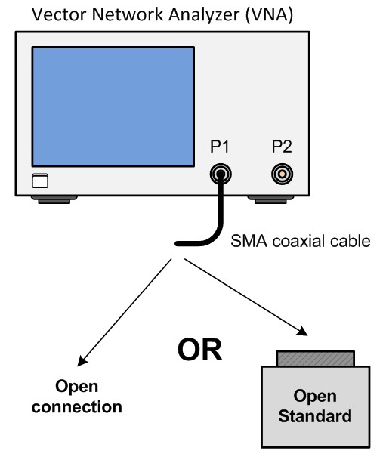
Figure 3 – OPEN Response Calibration Setup

SHORT Response Calibration (Reflection Test)
In a SHORT response calibration, calibration data is measured by connecting a SHORT standard, respectively, to the desired test port. For frequency response, this calibration effectively eliminates the reflection tracking errors in a reflection test using the desired port from the test setup as shown in Figure 4.
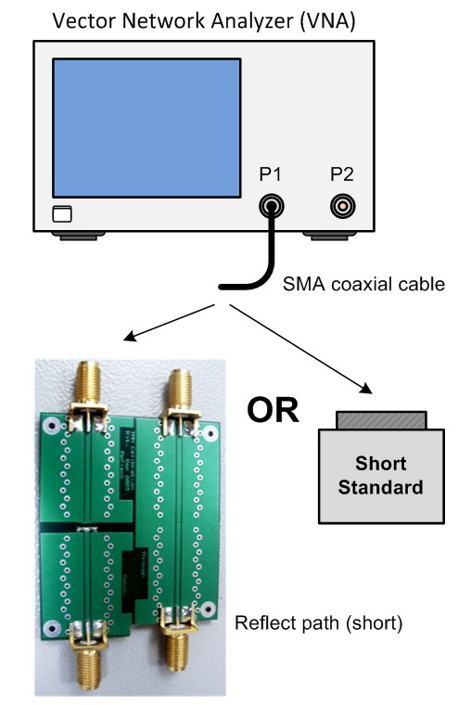
Figure 4 – SHORT Response Calibration Setup

LOAD Calibration
In a LOAD response calibration, calibration data is measured by connecting a LOAD standard or the MATCH load of the TRM calibration kit to the desired test port. This calibration effectively improves the accuracy in a transmission and reflection measurement of a device that has high insertion loss as shown in Figure 5.
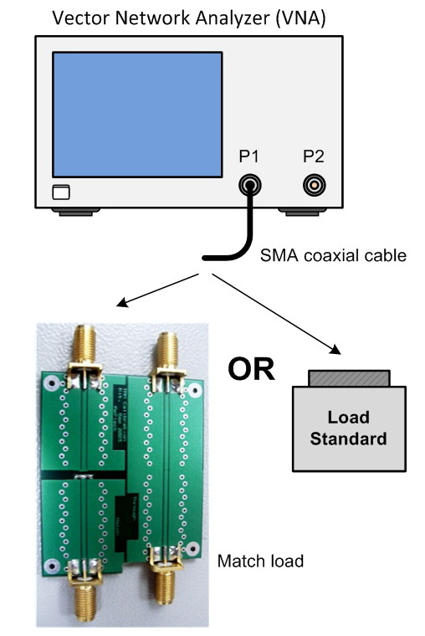
Figure 5 – LOAD Calibration Setup

THRU Response Calibration (Transmission Test)
In a THRU response calibration, calibration data is measured by connecting a THRU standard to the desired test port. This calibration effectively eliminates the frequency response transmission tracking error from the test setup in a transmission test using that port as shown in Figure 6.
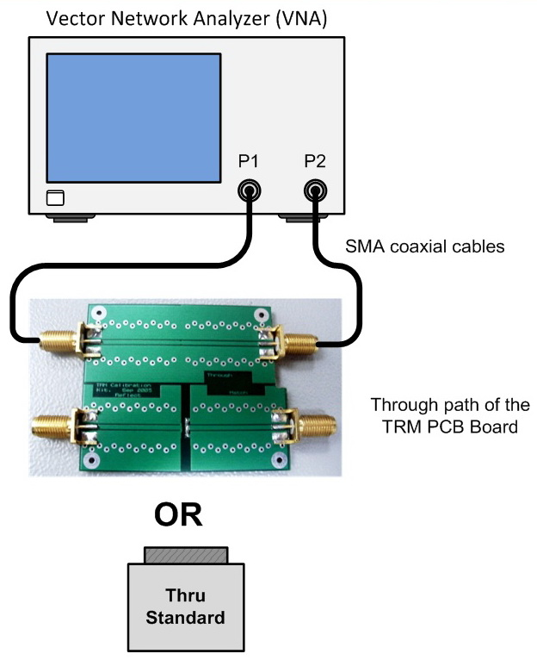
Figure 6 – THRU Response Calibration Setup
Table 1 – Summary of Full Two-Port Calibration ^{[1]}
Full 2-Port Calibration | - OPEN  - SHORT^{[1]}  - LOAD^{[2]}  - THRU | Following 12 error terms:  - Directivity  - Isolation ^{[2]}  - Source Match  - Load Match  - Transmission Tracking  - Reflection Tracking | S11,S21,S12,S22  (All S-parameters at the two ports) | - Highly accurate  two-port measurement  - Quick calibration with low chance of operator errors
 |  |  |  | - A two-port measurement with the highest degree of accuracy
Note:
You may select whether or not to carry out an isolation calibration.
^{[1]} A general principle is to use an open standard if the impedance of the device is larger than 50 Ω and a short standard if it is less.
^{[2]} Used only when an isolation calibration is carried out. Isolation calibration is not performed when the two-port ECal module and ECal Assistant VBA macro are used.

Calibration Procedure

Note:
The following steps to set up a VNA are based on the Keysight E5061A ENA-L RF Network Analyzer model. Preset the instrument to its default state before performing the following calibration by selecting the [Preset] button followed by {OK}.
E5061A setting: “[ ]”: Hardkey; “{ }”: Softkey
Preset: [Preset] > {OK}
- Press Channel Next or Channel Prev to select the channel for which you want to perform the calibration.
- Press Cal.
- Press Calibrate.
- Press 2-Port Cal.
- Press Reflection.
E5061A setting: “[ ]”: Hardkey; “{ }”: Softkey
Calibrate: [Cal] > {Calibrate} > {2-Port Cal} > {Reflection}
- Connect an OPEN calibration standard to test port x (the connector to which the DUT will be connected).

Note:
If this part of calibration is performed using the TRM calibration kit, the SMA coaxial cable will not be connected to anything. In this situation, for open measurement, the correction will be only up until the SMA connector and not to the PCB path connecting the DUT.
- Press Port x Open to start the calibration measurement (x denotes the test port to which the standard is connected).
E5061A setting: “[ ]”: Hardkey; “{ }”: Softkey
Port: {Port x Open}
- Disconnect the OPEN calibration standard that was connected in Step 6 and replace it with a SHORT calibration standard.
- Press Port x Short to start the calibration measurement (x denotes the test port to which the standard is connected).
E5061A setting: “[ ]”: Hardkey; “{ }”: Softkey
Port: {Port x Open}
- Disconnect the SHORT calibration standard that was connected in Step 6 and replace it with a LOAD calibration standard.
- Press Port x Load to start the calibration measurement (x denotes the test port to which the standard is connected).
E5061A setting: “[ ]”: Hardkey; “{ }”: Softkey
Port: {Port x Load}
- Repeat Step 6 to Step 11 for the other port.

- Press Return.
E5061A setting: “[ ]”: Hardkey; “{ }”: Softkey
Return: {Return}
- Press Transmission.
E5061A setting: “[ ]”: Hardkey; “{ }”: Softkey
Calibrate: {Transmission}
- Make a THRU connection between the two ports.
- Press Port 1-2 Thru to start the calibration measurement.
E5061A setting: “[ ]”: Hardkey; “{ }”: Softkey
Port: {Port 1-2 Thru}
- Press Return.
E5061A setting: “[ ]”: Hardkey; “{ }”: Softkey
Return: {Return}
- If an isolation calibration must be performed using a LOAD standard, follow the procedure below.
  - Press Isolation (Optional).
E5061A setting: “[ ]”: Hardkey; “{ }”: Softkey
Calibration: {Isolation (Optional}

  - Connect a LOAD standard to each of the two test ports.
  - Press Port 1-2 Isol to start the calibration measurement.
E5061A setting: “[ ]”: Hardkey; “{ }”: Softkey
Port: {Port 1-2 Isol}

- Press Return.
E5061A setting: “[ ]”: Hardkey; “{ }”: Softkey
Return: {Return}
- Press Done to terminate the full two-port calibration process. Upon pressing the key, the calibration coefficients will be calculated and saved. The error correction function will also be automatically enabled.
E5061A setting: “[ ]”: Hardkey; “{ }”: Softkey
Done: {Done}

Note:
- An asterisk (*) in the upper right of the softkey indicates that, if you select the test port and execute the acquisition of the calibration coefficient (press Done), the existing calibration coefficient will be cleared.
- The above calibration state can be saved by using the following procedure:
- Press Save/Recall.
- Press Save State.
E5061A setting: “[ ]”: Hardkey; “{ }”: Softkey
Save: [Save/Recall] > {Save State}
- When you want to use a pre-defined file name (example: State01.sta - State08.sta, Autorec.sta), press State01 − State08 or Autorec.
E5061A setting: “[ ]”: Hardkey; “{ }”: Softkey
State: {State0x or Autorec}

Note:
- If “A:\Autorec.sta” or “D:\Autorec.sta” is found on the system at startup, the E5061A/E5062A is automatically configured using the saved settings. When both files are found, “A:\Autorec.sta” is recalled. To disable the auto recall function, delete the Autorec.sta files.
- An asterisk (*) in the upper right of the softkey indicates that, the corresponding file of the softkey already exist. If you save into the existing file, the existing file is copied as “backup.sta” and then it is overwritten.

