ME1000 RF Circuit Design
Lab 9
End-to-End RF Transceiver Measurement
This courseware product contains scholarly and technical information and is protected by copyright laws and international treaties. No part of this publication may be reproduced by any means, be it transmitted, transcribed, photocopied, stored in a retrieval system, or translated into any language in any form, without the prior written permission of Acehub Vista Sdn. Bhd.

The use of the courseware product and all other products developed and/or distributed by Acehub Vista Sdn. Bhd. are subject to the applicable License Agreement.

For further information, see the Courseware Product License Agreement.

Objective
- To analyze the signal flow through each module in the transceiver chain

Equipment Required
- Keysight N9320B 3 GHz RF Spectrum Analyzer
- Keysight N9310A RF Signal Generator
- ME1000 RF Transceiver Kit (Transmitter unit and Receiver unit)
- 2 × 868 MHz Antenna

Accessories Required
- 2 × SMA(m)-to-SMA(m) coaxial cable
- 9 × SMA(m)-to-SMA(m) jumper cable
- 2 × USB cable
- A PC running Microsoft® Windows XP/Vista®, pre-installed with the RF Trainer Control Panel software

IMPORTANT:
Turn off the training kit when not in use. The kit will turn off automatically when no mouse or keyboard action is detected for more than 10 minutes. Always ensure that the casing is grounded and the cover is latched up before powering up the device.

Introduction

Basic Equipment Setup
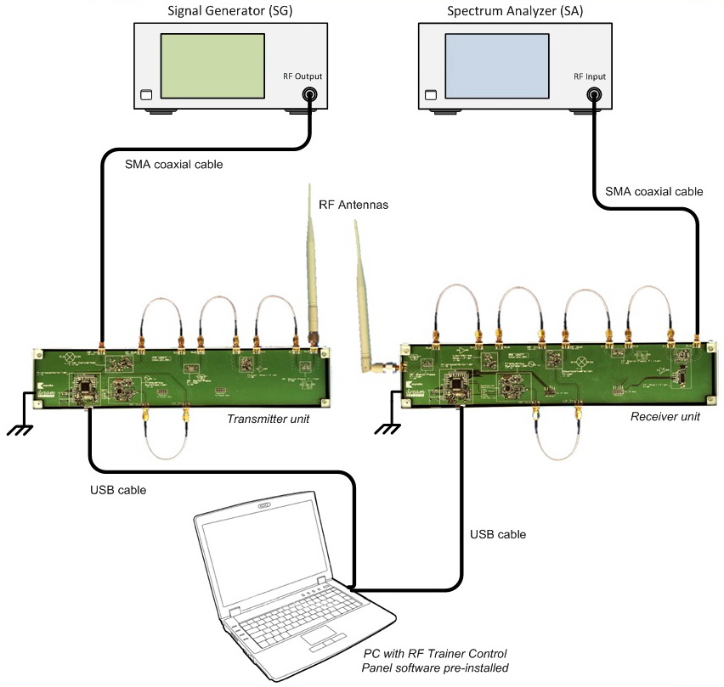
Figure 1 – General Equipment Configuration for End-To-End Transceiver Unit Measurement Using a Spectrum Analyzer (SA)

Installing the RF Trainer Control Panel Software
- Run the setup.exe installer from the supplied CD-ROM if you have not installed the RF Trainer Control Panel software.
- Start two control panels by clicking the RF_Trainer icon on your PC desktop twice. One control panel will control the transmitter unit, while the other will control the receiver unit.
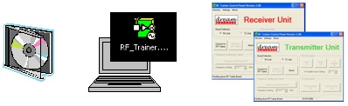

Transmitter Unit Setup
- Connect your PC to the transmitter unit via a USB cable.
- Select the TX Unit from one of the two control panels and click Connect to RF Trainer. The green LED will blink once on the Control Unit of the transmitter unit indicating a successful connection.
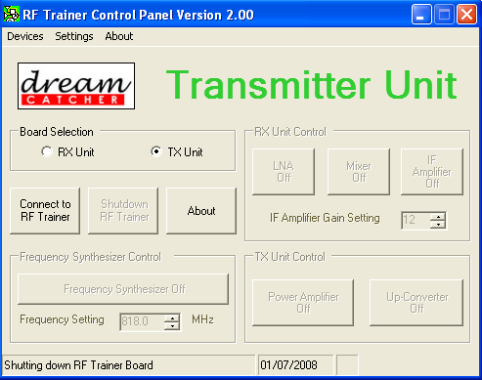

Verification of the Transmitter Unit
- Click Frequency Synthesizer Off/On to power up the frequency synthesizer. Set frequency to
818 MHz.
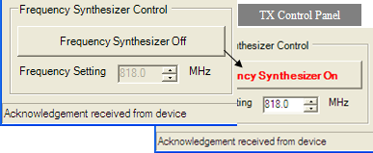

Synthesizer Verification
- Connect the SA to the Synthesizer Out port.
Center frequency: 818 MHz
Span: 10 MHz

N9320B setting: “[ ]”: Hardkey; “{ }”: Softkey
Preset to default settings: [Preset/System] > {Preset}
Center frequency: [FREQUENCY] > {Center Freq} > [818] > {MHZ}
Span: [SPAN] > [10] > {MHZ}

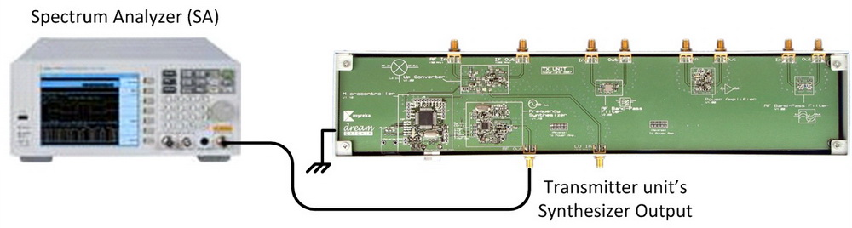

- Check if the output signal from the synthesizer is correct.
- Click Up-Converter Off/On to power up the mixer.
- Reconnect the SA to the IF Out port.
- Use an SMA jumper cable to connect the Synthesizer Out port to the Mixer LO In port.
- Connect the signal generator (SG) (50 MHz, −15 dBm) to the Mixer RF In port.
Frequency: 50 MHz
Amplitude: −15 dBm

N9310A setting: “[ ]”: Hardkey; “{ }”: Softkey
Frequency: [Frequency] > [50] > {MHZ}
Amplitude: [Amplitude] > [+/-] > [15] > {dBm}

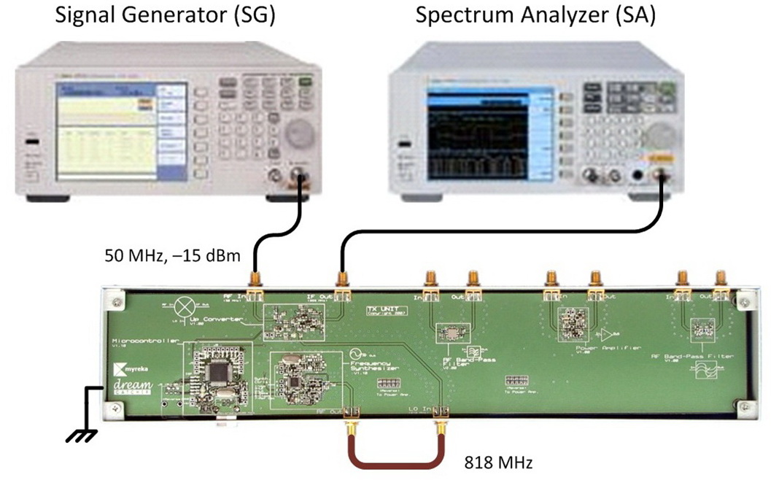
- Check the SA to see if the mixer produces any inter-modulation products, i.e., (±n818
± m50) MHz signals.

End-To-End Transmitter Verification
- Reconnect the SA to the Bandpass Filter Out port.
Center frequency: 868 MHz
Span: 20 MHz

N9320B setting: “[ ]”: Hardkey; “{ }”: Softkey
Center frequency: [FREQUENCY] > [868] > {MHZ}
Span: [SPAN] > [20] > {MHZ}

- Use the SMA jumper cables to connect all the ports as shown below.
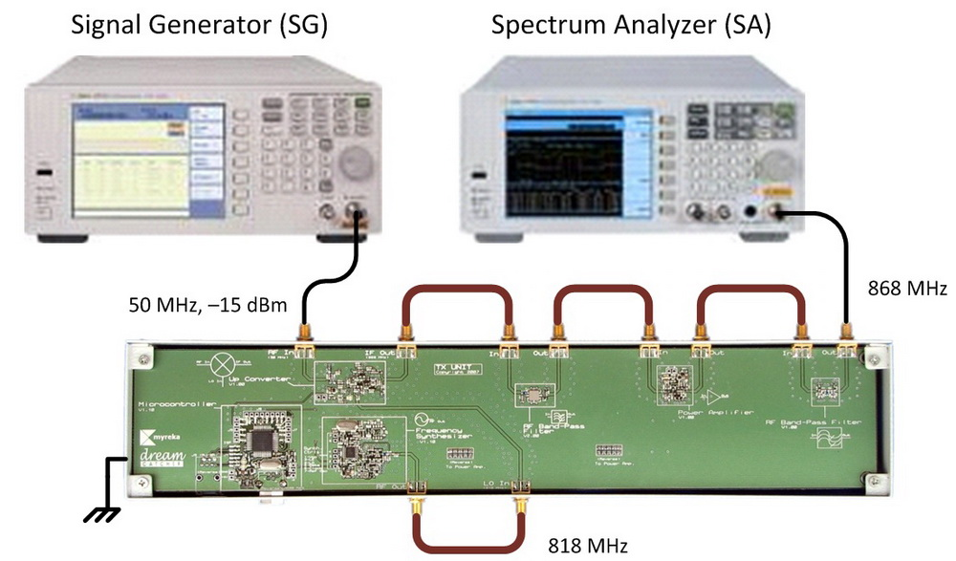
- Click Power Amplifier Off/On on the RF Trainer Control Panel to power up the power amplifier.
- Check the SA to see if the SG output is up-converted from 50 MHz to 868 MHz.

Exercises
- Vary the frequency setting of the frequency synthesizer and observe the signal output on the SA. Does the 50 MHz input signal up-convert accordingly? Explain your observation.
To capture the frequency spectrum on the SA while varying the frequency synthesizer setting, set up the SA as follows:

N9320B setup: [View/Trace] > [Max Hold]

This setting will store the display of all previous peak signals captured.

- Vary the synthesizer setting from the lowest to the highest (using the up/down button) and observe the frequency spectrum. Pay attention to the RF signal that is lower than the others are.
Note:
Use the marker function to measure the amplitude. Press [Peak Search] > {Next Peak}, {Next Pk Right}, or {Next Pk Left}.

Determine the 3 dB bandwidth of the transmitter from the spectrum captured on the spectrum analyzer.

Place a marker on the signal (at the lower frequency edge) which is 3 dB lower than the highest peak on the spectrum by turning the front-panel knob. Then, press [Marker] > {Delta} > {Delta On}.

This will anchor the first marker and activate a second marker. Turn the knob again to move the second marker to another signal (at the upper frequency edge) which is also 3 dB lower than the highest peak on the spectrum.

Lower 3 dB frequency = __________ MHz
Upper 3 dB frequency = __________ MHz
3 dB bandwidth = __________ MHz

Receiver Unit Setup
- Connect your PC to the receiver unit via a USB cable.
Note:
The same PC can be used to make this second connection.
- Select the RX Unit from the other control panel and click Connect to RF Trainer. The green LED will blink once on the Control Unit of the transmitter unit indicating a successful connection.

Verification of Receiver Unit
- Click Frequency Synthesizer Off/On to power up the frequency synthesizer. Set the frequency to 818 MHz.
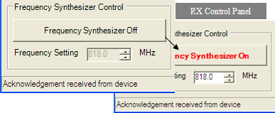

Synthesizer Verification
- Connect the SA to the Synthesizer Out port.
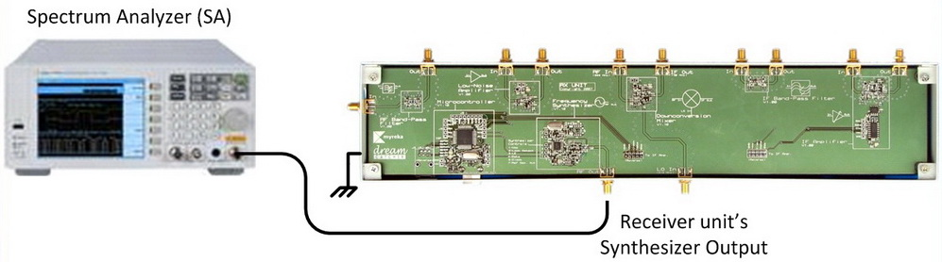
- Check if the output signal from the synthesizer is correct.

Mixer Verification
- Click Mixer Off/On to power up the Mixer.
- Reconnect the SA to the IF Out port.
- Use a SMA jumper cable to connect the Synthesizer Out port to the Mixer LO In port.

Connect the SG (868 MHz, −15 dBm) to Mixer RF In port.
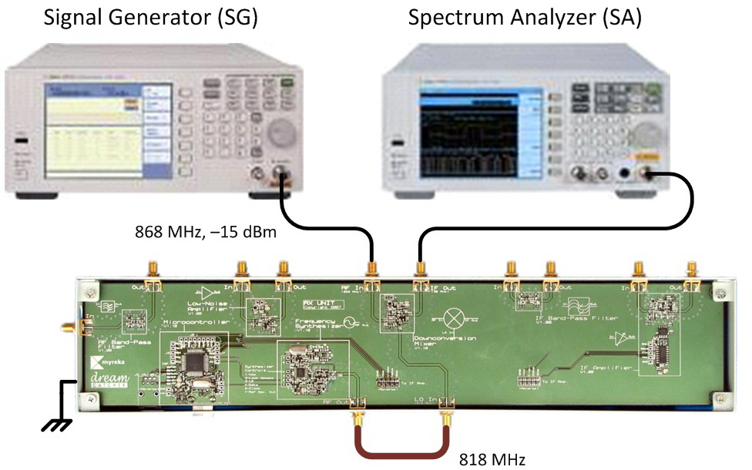
- Check the SA to see if the mixer produces inter-modulation products, i.e., (±n818 ± m868) MHz signals.

End-To-End Receiver Verification
- Reconnect the SA to the Band-pass Filter Out port.
- Reconnect the SG to the Band-pass Filter In port.
- Use the SMA jumper cables to connect all the ports as shown below.
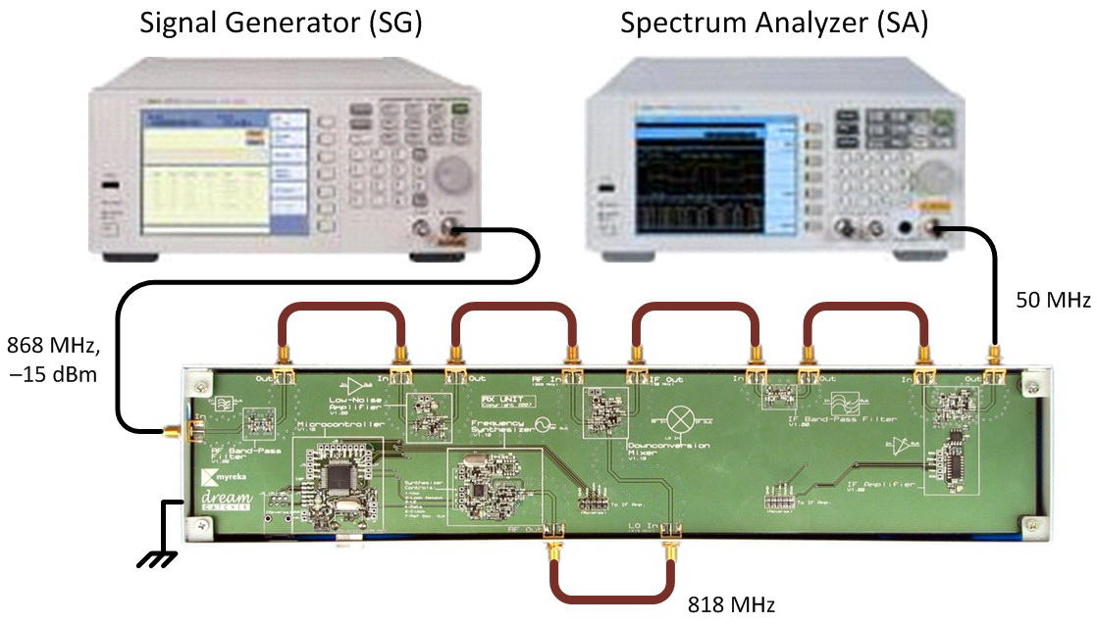
- Click LNA Off/On and IF Amplifier Off/On to power up the LNA and IF amplifier.
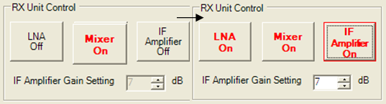
- Check the SA to see if the SG output is down-converted from 868 MHz to 50 MHz.
Note:
Adjust the IF amplifier gain to capture a larger signal on the SA.

Exercises
- Set the SG frequency to 867 MHz to simulate a different carrier. What do you need to do to get back the 50 MHz IF signal at the receiver output?
What are the advantages of a super-heterodyne receiver?
- Reconnect the SG to the input of the LNA as shown below:
Set the SG frequency to 768 MHz. Do you get a 50 MHz signal on the SA? Explain your observation.
- What is this 768 MHz signal called? Explain the problem faced with the presence of this signal and how this problem is avoided in the receiver unit architecture.

End-To-End RF Transceiver Setup
- Connect one antenna to the transmitter unit.
- Connect the other antenna to the receiver unit.
- Separate the units to about 0.5 m apart.
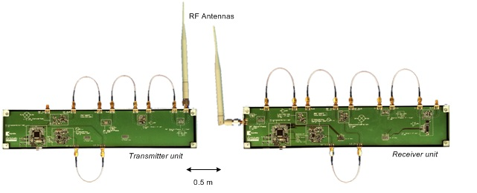

- Connect and power up the SG as shown below.
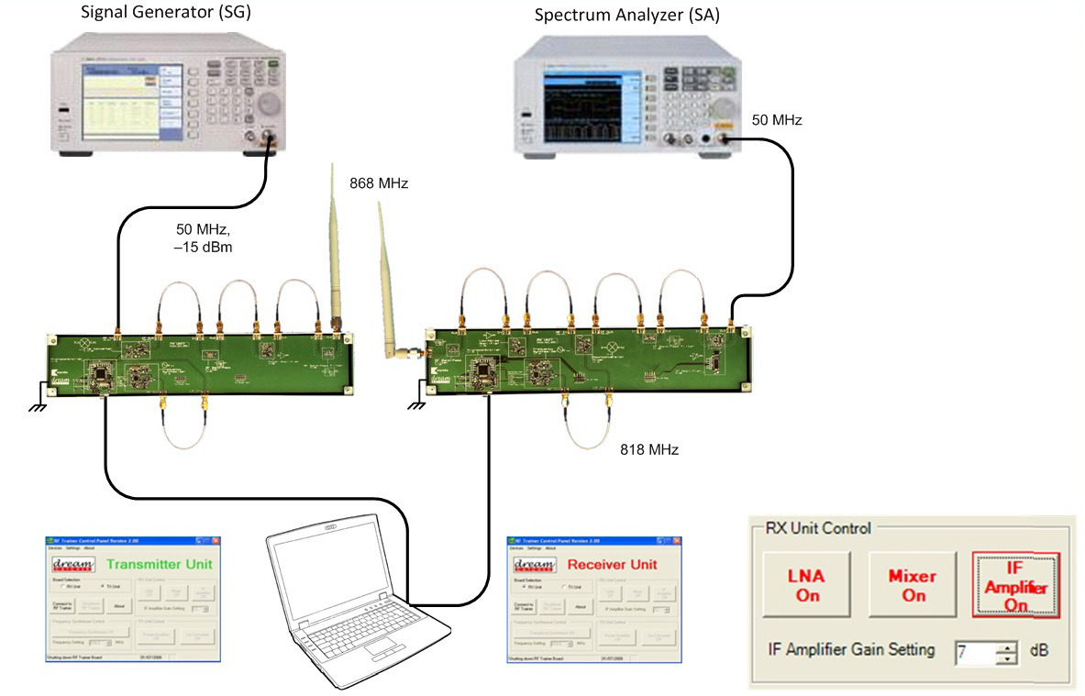
- Check the SA to see if the SG output from the transmitter unit is received at the receiver unit. To do this, you have to power up the up-converter, power amplifier, and frequency synthesizer and set it at 818 MHz on the transmitter unit as well as the LNA, mixer, IF amplifier, and frequency synthesizer and set it at 818 MHz on the receiver unit.
- The received signal is in the region of −50 dBm. Ensure that the noise floor of the SA is below this level. You might need to change the IF amplifier gain (for example to Level 8) if the received signal is too weak or your SA noise floor is too high.

Exercises
- Observe the presence of the signal on the SA. Use the Peak Search function to measure the signal frequency.
Note:
If the signal is too low, move either the transmitter and receiver unit closer to each other or increase the IF amplifier gain setting.
- Set the SA center frequency to 50 MHz, span to 2 MHz, and resolution bandwidth to 40 KHz.
Center frequency: 50 MHz
Span: 2 MHz
Resolution bandwidth: 40 kHz

N9320B setting: “[ ]”: Hardkey; “{ }”: Softkey
Center frequency: [FREQUENCY] > {Center Freq} > [50] > [MHZ]
Span: [SPAN] > [2] > [MHZ]
RBW: [BW/AVG] > [40] > [KHZ]

Set the SG to 50 MHz and turn on the frequency modulation (FM) with the following setting:

FM deviation: 80 KHz
FM rate: 80 KHz
FM source: Internal

N9320B setting: “[ ]”: Hardkey; “{ }”: Softkey
Frequency: [FREQUENCY] > [50] > [MHZ]
Modulation: [Mod On] > [Mod On/Off]
FM deviation: [FM] > {FM Dev} > [80] > [KHZ]
FM rate: {FM Rate} > [80] > [KHZ]
FM source: {FM Source} > {Internal}
FM modulation: {FM On} > [FM On/Off]

Determine the modulating frequency from the spectrum displayed on the SA.

- Reduce the FM rate to 70 kHz and observe the change on the SA. Increase the resolution bandwidth of the SA to 100 kHz. Are you still able to measure the modulating frequency? Why or why not?

