ME1000 RF Circuit Design
Lab 7
Measurement Automation Using
Keysight VEE
This courseware product contains scholarly and technical information and is protected by copyright laws and international treaties. No part of this publication may be reproduced by any means, be it transmitted, transcribed, photocopied, stored in a retrieval system, or translated into any language in any form, without the prior written permission of Acehub Vista Sdn. Bhd.

The use of the courseware product and all other products developed and/or distributed by Acehub Vista Sdn. Bhd. are subject to the applicable License Agreement.

For further information, see the Courseware Product License Agreement.

Objectives
- To introduce the Keysight VEE Pro software for measurement automation
- To introduce instrument control using the Keysight VEE Pro software

Equipment Required
- Keysight N9320B 3 GHz RF Spectrum Analyzer
- Keysight N9310A RF Signal Generator
- ME1000 RF Transceiver Kit (Transmitter unit and Receiver unit)

Accessories Required
- TRM standard calibration kit
- 2 × SMA(m)-to-SMA(m) coaxial cable
- 2 × SMA(m)-to-SMA(m) jumper cable
- 4 × USB cable
- A PC running Microsoft® Windows XP/Vista®, pre-installed with the RF Trainer Control Panel, Keysight IO Libraries Suite, Keysight VEE Pro Runtime, and Measurement Automation GUI software

IMPORTANT:
Turn off the training kit when not in use. The kit will turn off automatically when no mouse or keyboard action is detected for more than 10 minutes. Always ensure that the casing is grounded and the cover is latched up before powering up the device.

Introduction

What is the Keysight VEE Pro?
The Keysight VEE Pro is an easy-to-use but powerful graphical programming language designed specifically for test and measurement applications. The Keysight VEE Pro is incredibly easy to learn. You select and edit graphical objects from pull-down menus and connect them to each other by lines. Data flows from left to right and sequence flows from top to bottom, just as in a flowchart. Programming tasks that would require hundreds of lines of code in traditional text languages are simplified to a few high-level objects, rapidly reducing your development time.
The Keysight VEE Pro automatically handles different data types, providing automatic conversion and giving you powerful data handling capabilities with minimum complex programming. With a few clicks on the mouse button, you can access hundreds of built-in functions to aid you in your program development. Apart from this, it comes with built-in MATLAB and .NET functions that further enhance your program. The Keysight VEE Pro also interfaces with Microsoft Excel and allows you to exchange data seamlessly.
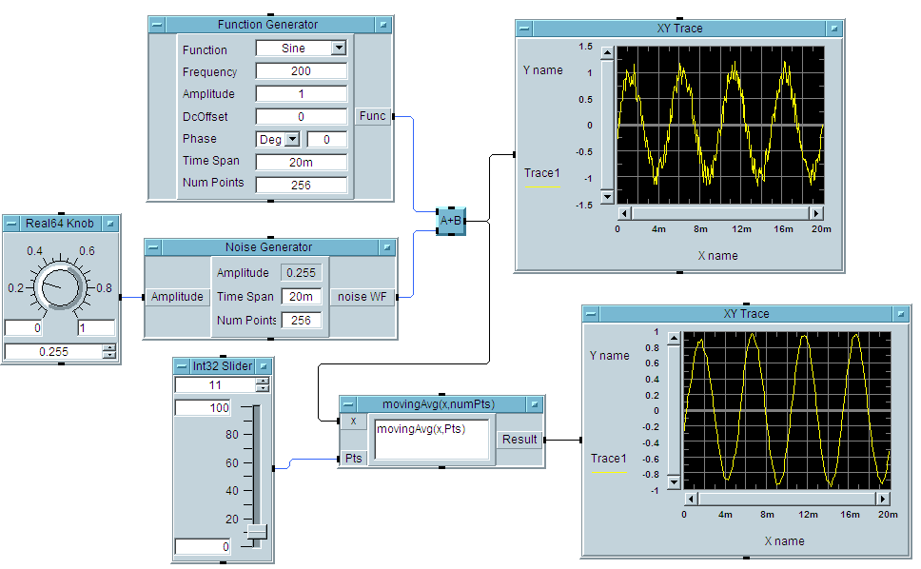
Figure 1 – An Example Program Developed in Keysight VEE Pro

Measurement Automation Graphical User Interface (GUI)
The measurement automation GUI is written in Keysight VEE Pro. The purpose of this application is to automate the measurements performed in the following labs:
- Lab A – Scalar Offset Calibration
Prerequisite: Completed Lab 1

This lab performs the following measurements automatically:
- Cable losses over a range of frequency
- PCB trace and SMA connector losses over a range of frequency

- Lab B – Power Amplifier Gain Measurement
Prerequisite: Completed Lab 2

This lab performs the following measurements automatically:
- Gain and gain compression measurement of power amplifier

- Lab C – RF Filter Measurement
Prerequisite: Completed Lab 4

This lab performs the following measurements automatically:
- Insertion loss and bandwidth of RF filter

- Lab D – Mixer Measurement
Prerequisite: Completed Lab 5

This lab performs the following measurements automatically:
- Gain compression of mixer

System Setup
- Software Setup
To install the software, please refer to the Read Me.txt file in the Measurement Automation folder in the CD that comes with the ME1000 RF Circuit Design courseware. After installing the software, click Measurement Automation.vxe and the GUI below will appear.
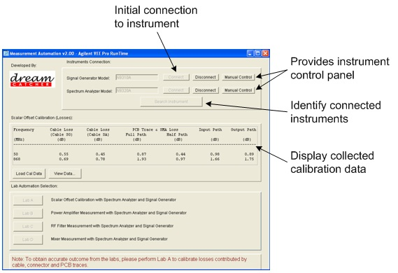
Figure 2 – Measurement Automation GUI
Note:
To view or modify the program, a copy of the Keysight VEE Pro software is required.
- Hardware setup
No extra drivers are required to connect to the N9310A and N9320B via the USB port to the PC — the Keysight IO Libraries Suite (version 14.1 or later) is installed in your PC during the software setup.
Refer to the following steps to accomplish the connection:
- Switch on the N9310A and N9320B.
- Connect the N9310A and N9320B USB Type-B port to a PC with USB cables via a USB hub.
- The PC will automatically detect the connected instruments as new hardware and will prompt the message “Found new hardware.” A “Found New Hardware Wizard” will be initiated automatically.

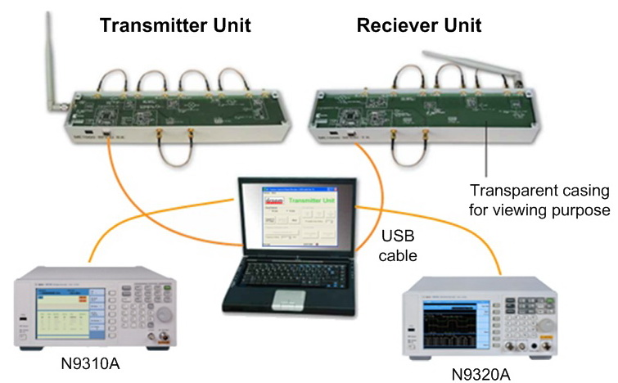
Figure 3 – Instrument and Training Kit Connections via a PC
- Operating the GUI
After the software and hardware have been set up, the following steps are necessary to initialize the software before the measurement automation labs can be carried out:
- Click Search Instrument to identify the connected instruments. If no instruments are found, check if the USB cables are connected properly and/or the instruments are powered up.
- Then, click Connect to initiate the connection.
- If there are stored calibration data, click Load Cal Data to load the data and click View Data to verify the calibration data.
- If no previous calibration data is saved, proceed to Lab A to perform the loss measurements contributed by the SMA coaxial cables, connectors, and PCB traces.

Lab A — Scalar Offset Calibration

Objective
To automate scalar offset calibration for cables, connectors and PCB traces.
Prerequisite: Completed Lab 1

The Need for Scalar Offset Calibrations
A typical frequency domain measurement of a device-under-test (DUT) is shown in Figure 4. When measuring the frequency response of a DUT, you will collect the power transferred from a SG to a SA via the DUT. To ensure that the data collected represents the actual response of the DUT only — and not portions related to the cables, connectors, and the losses within the measurement equipment itself — it is necessary to measure the total path loss of the interconnections from the equipment to the input and output terminals of the DUT.
In principle, the actual effect of the DUT is the measured value minus the losses due to the interconnections on both ends of the DUT. The process of accounting for the effect of the interconnection during a measurement is called Calibration. Since we are only interested in power measurement, the calibration process described here is known as Scalar Offset Calibration, and it is usually performed at various frequency of interest.
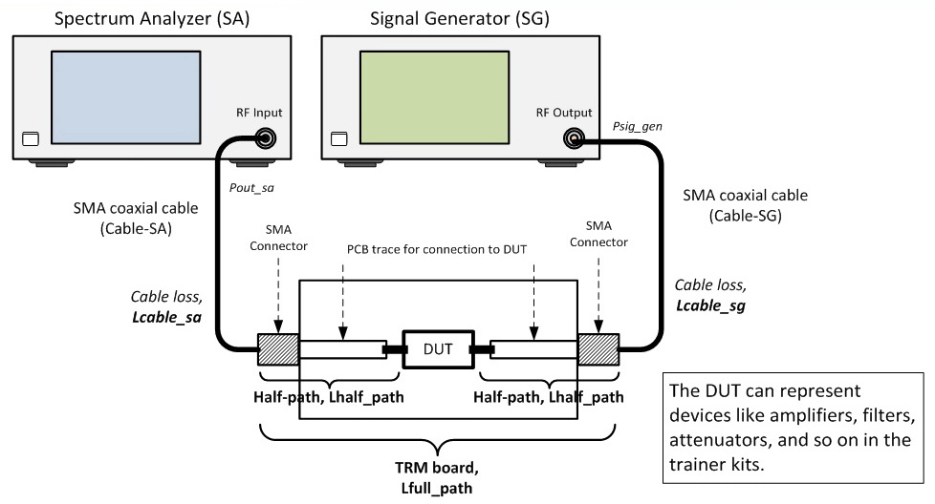
Figure 4 – The Need to Calibrate Scalar Offset of Cables, Connectors, and PCB Trace Losses

Path Loss Calibration
The total path loss in a frequency response measurement consists of two parts: the input path loss and the output path loss. Each path loss is in turn due to the coaxial cable and connector losses, and the loss from the copper trace on the printed circuit board (PCB) that leads to the DUT terminals. We can measure the path loss with the use of a calibration structure called the TRM (Through-Reflect-Match) board.
- Input path loss: Cable-SG loss and half of the loss from the TRM board (PCB traces and connectors).
- Output path loss: Cable-SA loss and half of the loss from the TRM board.
Assumption: The input and output paths of the TRM board are identical.
Since both input and output path loss consists of two parts, these two parts can be determined individually from the following procedures and summed up to give us the total path loss.

Procedures
- Measure the cable loss from the Cable-SG, Lcable_sg and Cable-SA, Lcable_sa.
- Measure the loss from the TRM board (through path).

Losses Contributed by Cables
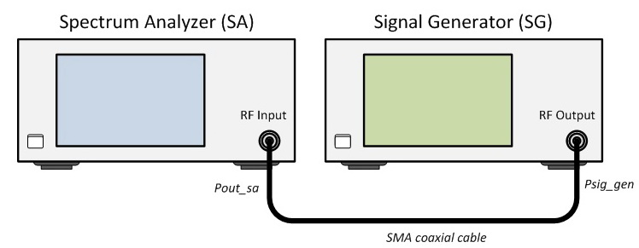
Figure 5 – SMA Coaxial Cable Loss Measurement Setup

Important:
Excessive input power levels can damage the SA. The threshold for damage is different for various models. The input setting can be as low as 20 dBm (0.1 W or 2.2 V). Observe the caution notice on the front panel of the equipment.
We can calibrate the cable loss before measuring any DUT by using the same equipment setup as shown in Figure 5. Click Lab A in the measurement automation GUI to start performing the lab.
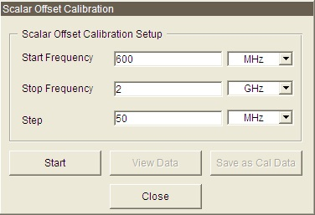
Figure 6 – Scalar Offset Calibration GUI

- Click Start in the GUI to begin the measurements as shown in Figure 6.
Note:
The automation software will perform the offset calibration for two fixed frequencies: at 50 MHz and 868 MHz, as the calibration offsets of these two frequencies are required for other labs to compensate for the incurred losses.
- Connect the SMA cable used to connect to the SG according to the diagram shown in Figure 5. This cable is known as Cable-SG. Press OK to proceed.
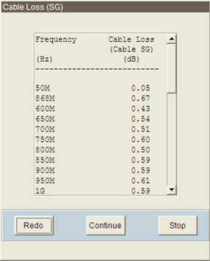
Figure 7 – Sample of Cable-SG Loss Data
- Click Redo to run the Cable-SG scalar offset calibration again if the reading is not within the acceptable range. Click Continue to carry out the following calibration, or click Stop to quit scalar offset calibration.
- Next, connect the SMA cable used to connect to the SA according to the diagram shown in Figure 5. This cable is known as Cable-SA. Click OK to proceed.
- Click Continue to proceed when all measurements are taken.

Losses Contributed by Connector and PCB Trace
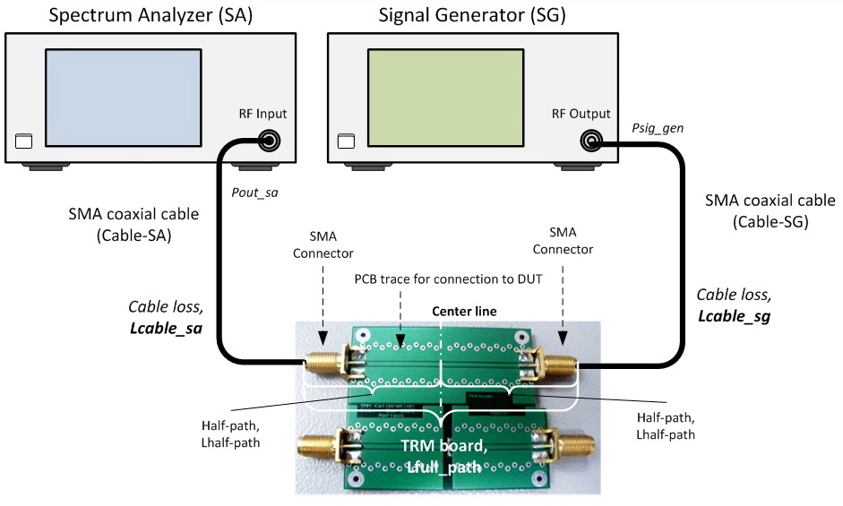
Figure 8 – SMA Connector and PCB Trace Losses Calibration
- Make the connection as shown in Figure 8.
- Click OK to proceed. A sample of the measurements is shown as below:
Note:
The automation software will perform the offset calibration for two fixed frequencies at 50 MHz and 868 MHz, as the calibration offsets of these two frequencies are required for other labs to compensate for the incurred losses.
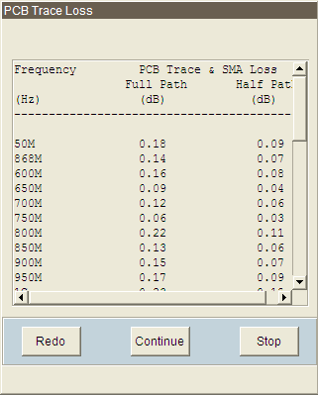
Figure 9 – Sample of PCB Trace and SMA Losses Measurement
- Click Continue to proceed to the main GUI.
- As shown in the GUI in Figure 6, click View Data to view the scalar offset data as shown in
Error: Reference source not found.
- The measurements from this connection are the total losses contributed by the Cable-SG,
Cable-SA, and the full path loss of PCB traces (represented by the TRM board).
- Full path loss for the PCB and SMA = Measured – SG amplitude setting – Cable losses (Cable-SG + Cable-SA)
- Half path loss for the PCB and SMA = 0.5 * full path loss (Assumption: The input and output path loss are equal)
- Input path loss, Linput_path = Lcable_sg + Half-path loss (PCB and SMA)
- Output path loss, Loutput_path = Lcable_sa + Half-path loss (PCB and SMA)
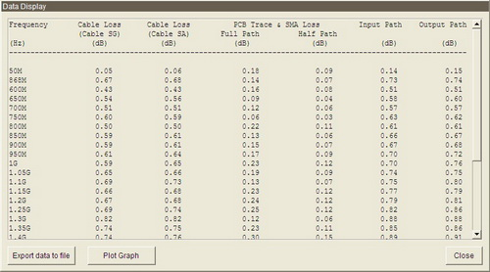
Figure 10 – Sample of Scalar Offset Calibration Data
- To view the individual loss graph, click Plot Graph in Figure 10. Then, select the graph of interest and click Plot as in Figure 11 to display the loss versus the frequency graph as shown below.
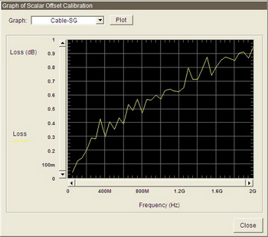
Figure 11 – Sample Cable-SG Loss Graph

Lab B — Power Amplifier (PA) Characterization

Objective
To automate the gain and gain compression measurements of a PA.
Prerequisite: Completed Lab 2

Basic Equipment Setup
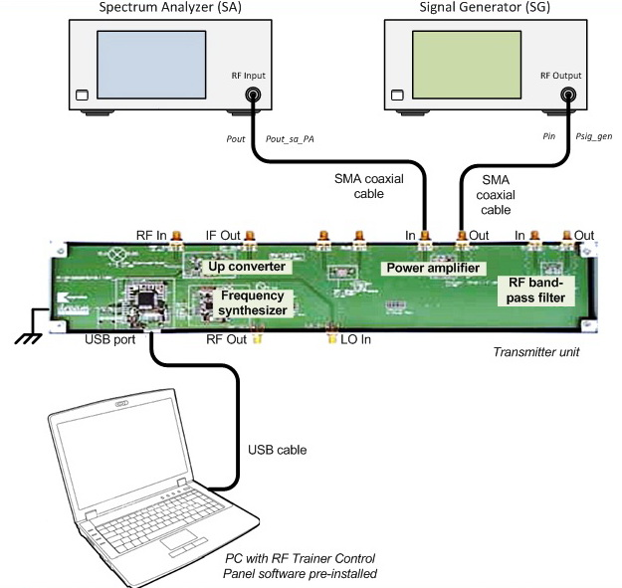
Figure 12 – General Equipment Configuration for PA Measurement Using a SA

Gain and Bandwidth Measurement
- The objective of this lab is to measure the gain over a range of frequency, and to characterize the bandwidth of the PA.
- Make the connection as shown in Figure 12.
- On your PC, launch the RF Trainer Control Panel. Select the TX Unit and click Connect to RF Trainer. Under the TX Unit Control area, click Power Amplifier Off/On to power up the PA. You will see the PA PCB LED light up on the trainer when it is powered on.
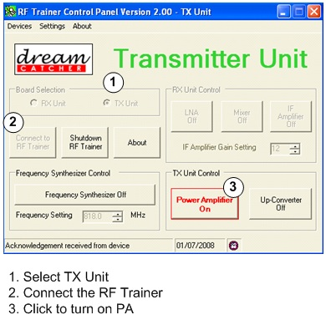
Figure 13 – Turn On the PA on the RF Trainer Control Panel
- Click Lab B and select OK after confirming the connection and Control Panel setting. Click PA Gain to start the measurements as shown in Figure 14 below:
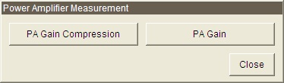
Figure 14 – PA Measurement GUI
- The default settings for the SG are:
Start frequency: 600 MHz
Stop frequency : 2 GHz
Step size: 50 MHz
Power level: −25 dBm

- The results are displayed as in Figure 15:
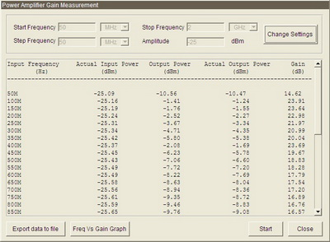
Figure 15 – An Example of the PA Gain Measurement
Amplifier input level = SG amplitude setting – Linput_path
Amplifier output level = SA measured level + Loutput_path
Linput_path = Lcable-SG + Lhalf_path (of PCB trace and SMA of TRM board)
Loutput_path = Lcable-SA + Lhalf_path (of PCB trace and SMA of TRM board)

- Click Freq Vs Gain Graph and the graph as shown below will be displayed. Use markers to determine the lower and upper frequency at –3 dB points.
Amplifier bandwidth = (upper 3 dB frequency) – (lower 3 dB frequency)

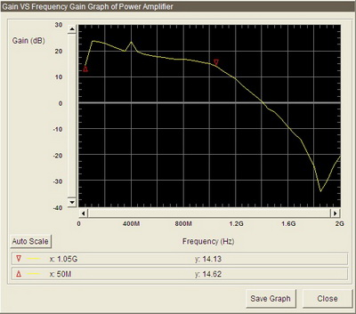
Figure 16 – An Example of Gain vs. Frequency Plot of the PA

Gain compression
- Set the SG according to the following settings:
Frequency: 868 MHz
Start power level: −20 dBm
Stop power level: 10 dBm
Step size: 1 dB

- Click Gain Compression to start the measurements. The result is as shown below.
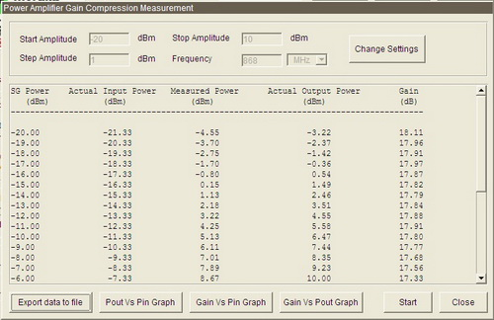
Figure 17 – An Example of the PA Gain Compression Measurement
- Plot Pout as a function of Pin by clicking Pout Vs Pin Graph in the Measurement Automation GUI. A sample of the plotted graph is as given below.
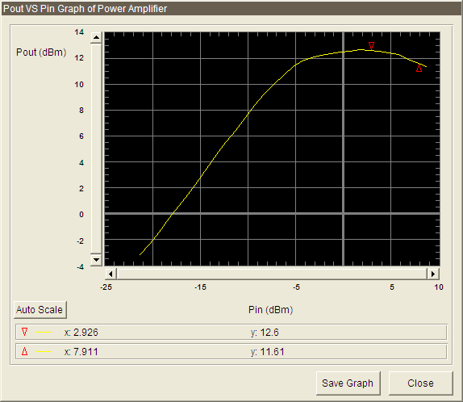
Figure 18 – An Example of Graph Plotted Using the PA Gain Compression Automation Test
- The 1 dB compression point is found at the point where the gain is 1 dB lower than the maximum gain. Place a marker at the point of the graph where the output power level is decreased by 1 dB from the highest level.
- Alternatively, the 1 dB compression point can be found using the method as shown in Figure 19.
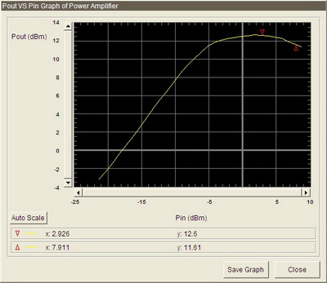
Figure 19 – An Example of the 1 dB Compression Plot of a PA

Lab C — Filter Characterization

Objective
To automate the bandwidth measurement of the RF bandpass filter v1.01
Prerequisite: Completed Lab 4

Basic Equipment Setup
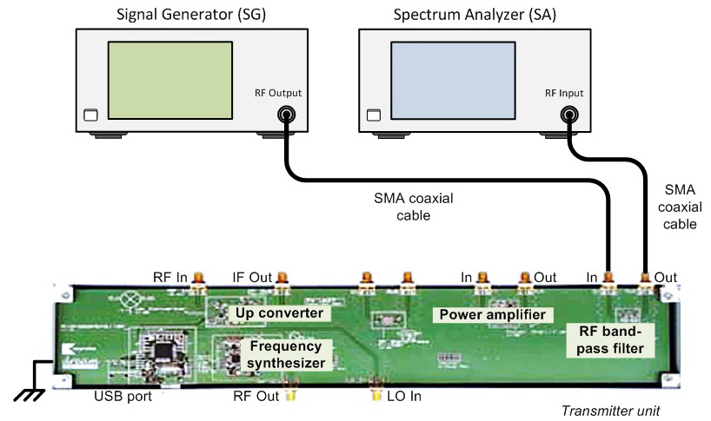
Figure 20 – General Equipment Configuration for RF Bandpass Filter Measurement Using a SA

Important:
Please use the RF Bandpass Filter v1.00 on the RF TX unit for this lab measurement.

Bandwidth Measurement with a SA
- Make the connection as shown in Figure 20 to determine the insertion loss of the RF filter. For more accurate results, you are required to perform Lab A before proceeding with this lab.
- Click Lab C and the set the settings of the SG as the following:
Start frequency: 600 MHz
Stop frequency: 2 GHz
Step size: 50 MHz
Power level: −25 dBm

- Click Start (as shown in Figure 21) to start the characterization process.
Filter input level = SG amplitude setting – Linput_path
Filter output level = SA measured level + Loutput_path
Linput_path = Lcable-SG + Lhalf_path (of PCB trace and SMA of TRM board)
Loutput_path = Lcable-SA + Lhalf_path (of PCB trace and SMA of TRM board)
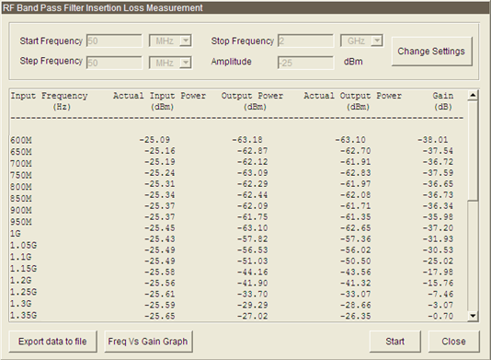
Figure 21 – An Example of Bandwidth Measurement for an RF Bandpass Filter
- Generate the plot of gain versus frequency by clicking Freq Vs Gain Graph. A sample of the collected plotted graph is as given below:
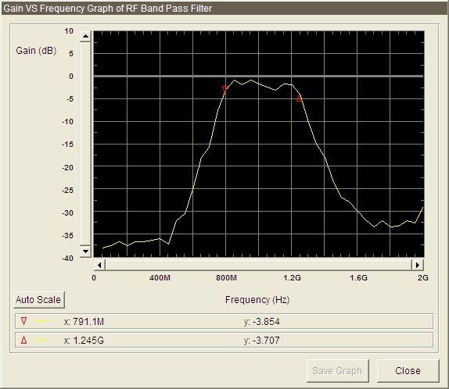
Figure 22 – An Example of Gain vs. Frequency Plot for an RF Bandpass Filter

Lab D — Mixer Characterization

Objective
To automate the gain compression measurement of the mixer
Prerequisite: Completed Lab 5

Basic Equipment Setup
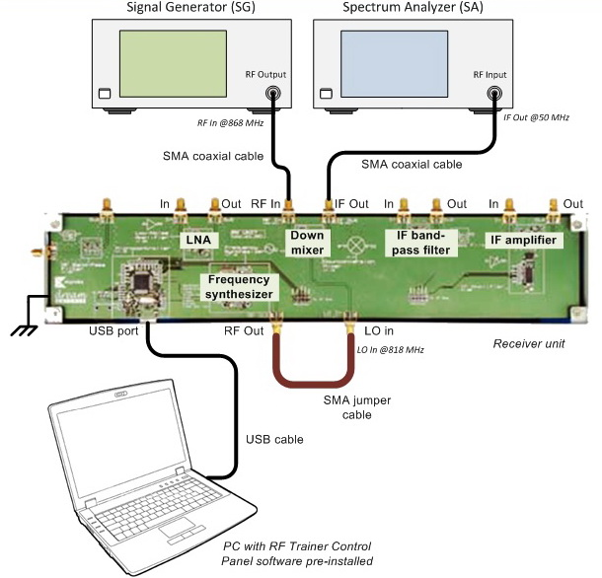
Figure 23 – General Hardware Configuration for Mixer Measurement Using a SA

Gain Compression Measurements
- Use the same setup as shown in Figure 23.
- On your PC, launch the RF Trainer Control Panel. Select the Rx Unit and click Connect to RF Trainer. Under the Frequency Synthesizer Control area, click Frequency Synthesizer Off/On to turn on the synthesizer. Set the frequency to 818 MHz. Then, turn on the mixer by clicking Mixer Off/On.
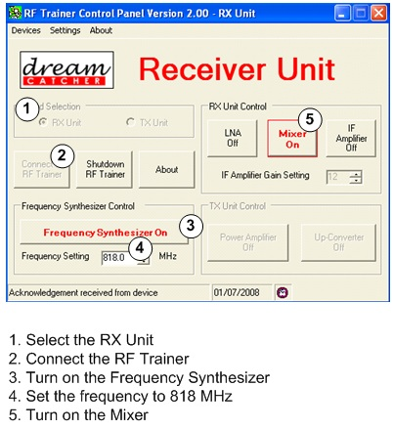
Figure 24 – Turning On the Frequency Synthesizer and Mixer of the Receiver Unit
- Set the SG according to the following settings:
CW frequency: 868 MHz
Start power level: –15 dBm
Stop power level: 5 dBm
Step size: 1 dB

- To automate data collection for the output power level of the filter at different input frequencies, click Lab D on the Measurement Automation GUI shown in Figure 2. Press Start to begin collecting data. A sample of the collected data is given below.
Mixer RF input power = SG power level – Linput_path @868 MHz
Mixer IF output power = SA measured level + Loutput_path @50 MHz

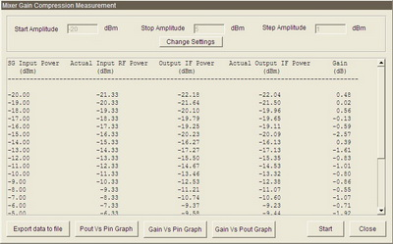
Figure 25 – Sample of Collected Data Using the Mixer Gain Compression Automation Test
- Generate the plot of Pout_IF as a function of Pin_RF by clicking Pout Vs Pin Graph. A sample of the plotted graph is shown below.
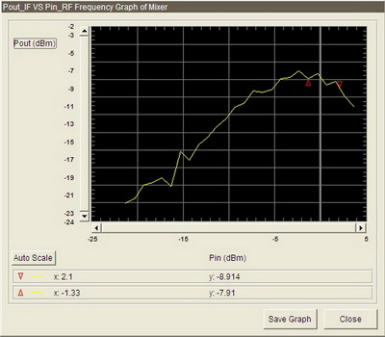
Figure 26 – A Plotted Graph Example Using the Mixer Gain Automation Test
To determine the 1 dB compression point, place a marker at the point where the Pout_IF decreased by 1 dB from the peak of the plot.

