ME1000 RF Circuit Design
Lab 3
Low-Noise Amplifier Characterization Using Spectrum Analyzer
This courseware product contains scholarly and technical information and is protected by copyright laws and international treaties. No part of this publication may be reproduced by any means, be it transmitted, transcribed, photocopied, stored in a retrieval system, or translated into any language in any form, without the prior written permission of Acehub Vista Sdn. Bhd.

The use of the courseware product and all other products developed and/or distributed by Acehub Vista Sdn. Bhd. are subject to the applicable License Agreement.

For further information, see the Courseware Product License Agreement.

Objective
- To measure the gain and isolation of a low-noise amplifier (LNA) via a spectrum analyzer (SA)

Equipment Required
- Keysight N9320B 3 GHz RF Spectrum Analyzer
- Keysight N9310A RF Signal Generator
- ME1000 RF Transceiver Kit (Receiver Unit)

Accessories Required
- 2 × SMA(m)-to-SMA(m) coaxial cable
- 1 × USB cable
- A PC running Microsoft® Windows® XP/Vista, pre-installed with the RF Trainer Control Panel software

IMPORTANT:
Turn off the training kit when not in use. The kit will turn off automatically when no mouse or keyboard action is detected for more than 10 minutes. Always ensure that the casing is grounded and the cover is latched up before powering up the device.

Introduction

Basic Equipment Setup
Figure 1 – General Equipment Configuration for LNA Measurement Using a SA

Gain Measurement with a SA
Make the connection as shown in Figure 1 to determine the gain of the LNA. You must use the value of the cable/connector/PCB trace losses from the previous lab.
- Use the following settings for the SG:
CW frequency: 868 MHz
Power: –15 dBm

N9310A setting: “[ ]”: Hardkey; “{ }”: Softkey
Preset to default settings: [Preset]
Frequency: [Frequency] > [868] > {MHZ}
Amplitude: [Amplitude] > [+/-] > [15] > {dBm}
Turn on output: [RF On/Off]

- Use the following settings for the SA:
Centre frequency: 868 MHz
Span: 10 MHz
Input attenuation: 10 dB (or auto)
RBW: 100 kHz (or auto)
Averaging: On

N9320B setting: “[ ]”: Hardkey; “{ }”: Softkey
Preset to default settings: [Preset/System] > {Preset}
Center frequency: [FREQUENCY] > [868] > {MHZ}
Span: [SPAN] > [10] > {MHZ}
Attenuation: [AMPLITUDE] > {Attenuation} > [10] > {dB}
RBW: [BW/AVG] > {Res BW} > {100} > {KHZ}
Averaging: [BW/AVG] > {Average}

- On your PC, launch the RF Trainer Control Panel. Select the RX Unit from the board selection and click Connect to RF Trainer. In the RX Unit Control area, click LNA Off/On to power up the LNA. You will see the LNA PCB LED light up on the trainer kit when it is powered on.

Exercises
- What is the peak frequency and power display on the SA? Ignore the harmonic frequencies that appeared on the SA.
Peak fundamental frequency = __________ MHz
Output power level, Pout_sa_LNA = __________ dBm

- What is the measured gain of the LNA when the input power is –15 dBm?
Gain @868 MHz = Actual LNA Output power, Pout – Actual LNA Input power, Pin
= (Pout_sa_LNA + Loutput_path) − (Psig_gen – Linput_path)
= (__________ dBm + __________ dB) − (−15 dBm − __________ dB)
= __________ dB
Where,
Loutput_path = Lcable_sa + Lhalf_path
(Cable/Connector/PCB trace losses found previously)

Linput_path = Lcable_sg + Lhalf_path
(Cable/Connector/PCB trace losses found previously)

- Compare the results measured with the VNA. Are they the same?

Isolation Measurement

Isolation Measurement Equipment Setup
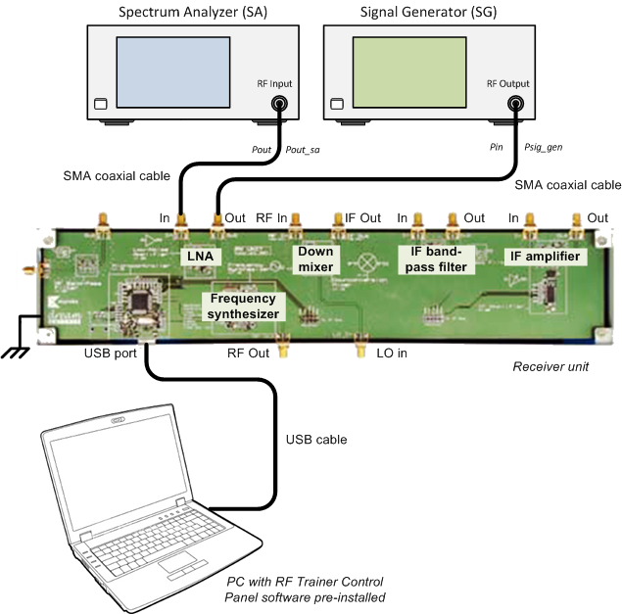
Figure 2 – Equipment Configuration for LNA Isolation Measurement
Make the connection as shown in Figure 2, by swapping the SG and SA, in order to determine the isolation of the LNA. You must also use the value of cable/connector/PCB trace losses, (Lcable and Lc_pcb) from the previous lab. Ensure that the DC power supply to the LNA is turned off before attempting to remove any connection. Click LNA Off/On in the RF Trainer Control Panel to turn off the DC power supply to the LNA.

- Use the following settings for the SG:
CW Frequency: 868 MHz
Power: –15 dBm

N9310A setting: “[ ]”: Hardkey; “{ }”: Softkey
Frequency: [Frequency] > [868] > {MHZ}
Amplitude: [Amplitude] > [+/-] > [15] > {dBm}

- Use the following settings for the SA:
Centre frequency: 868 MHz
Span: 10 MHz
Input attenuation: 10 dB (or auto)
RBW: 100 kHz (or auto)
Averaging: On

N9320B setting: “[ ]”: Hardkey; “{ }”: Softkey
Center frequency: [FREQUENCY] > [868] > {MHZ}
Span: [SPAN] > [10] > {MHZ}
Attenuation: [AMPLITUDE] > {Attenuation} > [10] > {dB}
RBW: [BW/AVG] > {Res BW} > {100} > {KHZ}
Averaging: [BW/AVG] > {Average}

- On your PC, launch the RF Trainer Control Panel. Select RX Unit from the board selection and click Connect to RF Trainer. In the RX Unit Control area, click LNA Off/On to power up the LNA. You will see the LNA PCB LED light up on the trainer kit when it is powered on.

Exercises
- What is the frequency and power display on the SA? Ignore the harmonic frequencies that appeared on the SA.
Peak fundamental frequency = __________ MHz
Output power level, Pout_sa_LNA = __________ dBm

- What is the measured isolation of the LNA when input power is –15 dBm?
Isolation@868MHz = Actual LNA Output power, Pout – Actual LNA Input power, Pin
= (Pout_sa_LNA + Loutput_path) − (Psig_gen – Linput_path)
= (__________dBm + __________ dB) − (−15 dBm − __________ dB)
= __________ dB

- Compare the results measured with the VNA. Are they the same?

References
- Presentation slides, “A Seminar on RF Measurement – Spectrum Analysis Basics,” Keysight Technologies, 2001
- Thomas H. Lee, “Planar Microwave Engineering,” Cambridge University Press, 2004
- David M. Pozar, “Microwave Engineering,” 3rd Edition, John Wiley & Sons, 2005
- Application Note 1354, “Practical Noise-Figure Measurement and Analysis for Low-Noise Amplifier Designs,” Keysight Technologies

