ME1000 RF Circuit Design

Tutorial 9

General Small-Signal
Amplifier Design
(Solution)

This courseware product contains scholarly and technical information and is protected by copyright laws and international treaties. No part of this publication may be reproduced by any means, be it transmitted, transcribed, photocopied, stored in a retrieval system, or translated into any language in any form, without the prior written permission of Acehub Vista Sdn. Bhd.

The use of the courseware product and all other products developed and/or distributed by Acehub Vista Sdn. Bhd. are subject to the applicable License Agreement.

For further information, see the Courseware Product License Agreement.

Question 1
A silicon bipolar junction transistor amplifier has the following parameters at 800MHz:
Z_{m}=43.352 + j31.792 , F_{m}=1.216 (0.8493dB), R_{e}=4.737Ω.

S₁₁ = 0.6<148º
S₂₁ = 2.95<-50º
S₁₂ = 0.09<120º
S₂₂ = 0.6<-20º
Z_{o} = 50Ω

Design a low-noise amplifier with power gain not less than 6, noise figure less than 2.0dB and input mismatch better than 2.5. The load and source impedance connected to the amplifier are 300Ω and 50Ω respectively.

Solution
S₁₁ = -0.5088 + 0.318i S₁₂ = -0.045 + 0.0779i
S₂₁ = 1.8962 - 2.2598i S₂₂ = 0.5638 - 0.2025i

D = S₁₁∙S₂₂ - S₁₂∙S₂₁

D = −0.3124+ 0.0342i |D| = 0.3143

K = $\frac{1−(|S_{\text{11}}|)^{2}−(|S_{\text{22}}|)^{2}+(|D|)^{2}}{2⋅|S_{\text{21}}⋅S_{\text{12}}|}$
K = 0.7134

Since K<1 and |D| <1, the amplifier fails the Rollette Stability Test. It is thus conditionally stable.

Finding the Load Stability Circle parameters

CL:$\frac{(\overline{S_{\text{22}}−D⋅\overline{S_{\text{11}}})}}{(|S_{\text{22}}|)^{2}−(|D|)^{2}}$ RL: $\left|\frac{S_{\text{12}}⋅S_{\text{21}}}{(|S_{\text{22}}|)^{2}−(|D|)^{2}}\right|$

CL: 1.5082 + 1.0993i RL: 1.0164

Finding the Source Stability Circle parameters

CS:$\frac{(\overline{S_{\text{11}}−D⋅\overline{S_{\text{22}}})}}{(|S_{\text{11}}|)^{2}−(|D|)^{2}}$ RS: $\left|\frac{S_{\text{21}}⋅S_{\text{12}}}{(|S_{\text{11}}|)^{2}−(|D|)^{2}}\right|$

CS: -1.2467 - 1.3889i RS: 1.0164

Finding the Constant Power Gain circle parameters

C2 = $S_{\text{22}}−D⋅\overline{S_{\text{11}}}$ C2 = 0.394 – 0.2872i
g2 = $\frac{8}{|S_{\text{21}}|^{2}}$ g2 = 0.9193

C_{gp} = $\frac{1}{−1−(|S_{\text{22}}|)^{2}⋅g2+(|D|)^{2}⋅g2}⋅(−g2⋅\text{Re}(C2)+i⋅g2⋅\text{Im}(C2)$

C_{gp} =0.292 + 0.2129i

Rgp = $\frac{\sqrt{1−2⋅K⋅|S\text{12}⋅S\text{21}|⋅g2+(|S\text{12}⋅S\text{21}⋅g2|)^{2}}}{\left|−1−(|S_{\text{22}}|)^{2}⋅\text{g2}+(|D|)^{2}⋅\text{g2}\right|}$
Rgp = 0.6801

Finding suitable load impedance:

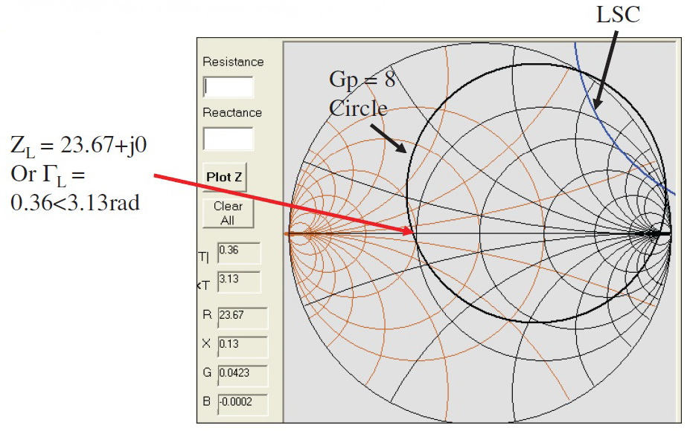

Finding the parameters for noise figure circles

Zsm = 43.352+ i∙31.792 Fm = 1.216 Re_LNA = 4.737

Tsm = $\frac{Z_{\text{sm}}−Z_{o}}{Z_{\text{sm}}+Z_{o}}$ = 0.0401 + 0.3269i

For FdB = 2.0

F2dB = 2.0

$$F1={\text{10}}^{\frac{F2\text{dB}}{\text{10}}}=1\text{.}\text{5849}$$

$$\text{Ni}1=\frac{Z_{o}}{4⋅\text{Re_}\text{LNA}}⋅(F1−\text{Fm})⋅\left[(|1+\text{Tsm}|)^{2}\right]=1\text{.}\text{1571}$$

$\text{Rf}1=\frac{\sqrt{(\text{Ni}1)^{2}+\text{Ni}1⋅\left[1−(|\text{Tsm}|)^{2}\right]}}{1+\text{Ni}1}$ $\text{Cf}1=\frac{\text{Tsm}}{1+\text{Ni}1}$

Cf1 = 0.0186 + 0.1515i Rf1 = 0.7138

Finding the parameters for input mismatch circle (ZL = 23.67 + j0) and fixing VSWRin = 2.0 < 2.5

ZL = 23.67+ i∙0 VSWRin = 2.0

TL = $\frac{Z_{L}−Z_{o}}{Z_{L}+Z_{o}}=−0\text{.}\text{3574}$

T1 = $\frac{S_{\text{11}}−D⋅\text{TL}}{1−S_{\text{22}}⋅\text{TL}}=−0\text{.}\text{5312}+0\text{.}\text{2424}i$

M1 = $1−{\left(\frac{\text{VSWRin}−1}{\text{VSWRin}+1}\right)}^{2}=0\text{.}\text{8889}$

Cvswrin = $\frac{M1⋅\overline{T1}}{1−(1−M1)⋅(|T1|)^{2}}=−0\text{.}\text{4908}−0\text{.}\text{2239}i$

Rvswrin = $\frac{\sqrt{1−M1}⋅\left[1−(|T1|)^{2}\right]}{1−(1−M1)⋅(|T1|)^{2}}=0\text{.}\text{2283}$

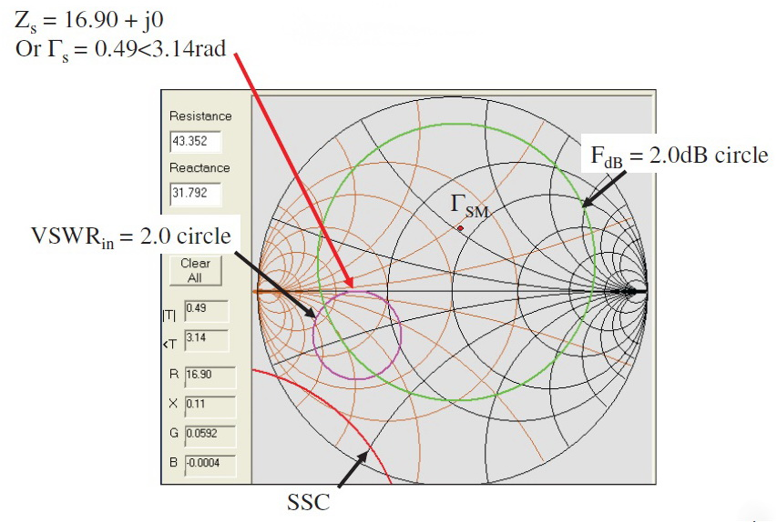

So the final selection for source and load impedance Are:

Zs = 16.90 + j0
ZL = 23.67 + j0
At 800MHz. Actual source and load impedance of

Z_{s(actual)} = 50 + j0 and Z_{L(actual)} = 300 + j0 has to be transformed to the above values using suitable impedance transformation network.

Question 2
An antenna with a source impedance of 25.845-j100.128 at 4GHz is connected to the input of an amplifier. The amplifier has the following S-parameters at 4GHz.
Z_{m}=47.5 + j10.8 , F_{m}=1.2 (0.7918dB), R_{e}=4.0Ω.
S₁₁ = 0.36<148º
S₂₁ = 1.57<27º
S₁₂ = 0.11<42º
S₂₂ = 0.67<-64º
Z_{o} = 50Ω

- Show that the amplifier is unconditionally stable.
- Design a maximum power gain amplifier with the antenna.
- Find the maximum power gain of the system, the transducer gain and the input mismatch factor.
- Also find the noise figure of the system.
- Is the noise figure and mismatch acceptable? Give your comments.

Solution
S-parameters at 4GHz:
S₁₁ = -0.305 + j0.191
S₂₁ = 1.399 + j0.713
S₁₂ = 0.082 + j0.074
S₂₂ = 0.294 – j0.602

D = S₁₁S₂₂-S₂₁S₁₂ = -0.036 +j0.0786
This shows that the amplifier is unconditionally stable
|D| = 0.087

$$K=\frac{1−|S_{\text{11}}|^{2}−|S_{\text{22}}|^{2}+|D|^{2}}{2|S_{\text{21}}S_{\text{12}}|}=1\text{.}\text{242}$$

Finding the source and load reflection coefficient for maximum power gain:
B₁ = S₁₁ – DS₂₂* = -0.247 +j0.190
A₁ = 1 + |S₁₁|² - |S₂₂|² - |D|² =0.673
$$Γ_{\text{sm}}=\frac{1}{2B_{2}}[A_{2}−\sqrt{A_{2^{2}}−4|B_{2}|^{2}}]=0\text{.}\text{342}+j0\text{.}\text{747}$$

Converting the reflection coefficients into impedance:
Z_{Lm} = $Z_{o}\left(\frac{1+Γ_{\text{Lm}}}{1−Γ_{\text{Lm}}}\right)=\text{16}\text{.}\text{382}+j\text{75}\text{.}\text{336}$
Z_{sm} = $Z_{o}\left(\frac{1+Γ_{\text{sm}}}{1−Γ_{\text{sm}}}\right)=\text{10}\text{.}\text{899}−j\text{16}\text{.}\text{253}$

Finding the maximum power gain:
G_{Pmax} = $\frac{|S_{\text{21}}|}{|S_{\text{12}}|}\left(K−\sqrt{K^{2}−1}\right)=7\text{.}\text{212}=8\text{.}\text{58}\text{dB}$
G_{P} = G_{T} = G_{A} = G_{Pmax} M =1

To find the noise figure:
$$G_{i}=\frac{R_{e}}{|Z_{m}|^{2}}=\frac{R_{e}}{R_{m^{2}}+X_{m^{2}}}=0\text{.}\text{001686}$$
$$F=F_{\text{min}}+\frac{G^{i}}{R_{s}}{\left|Z_{s}−Z_{m}\right|}^{2}=1\text{.}2+\frac{0\text{.}\text{001686}}{\text{10}\text{.}\text{899}}(\text{45}\text{.}\text{514})^{2}=1\text{.}\text{5204}$$
The noise figure is acceptable, it is considered low (F<1.6 or 2dB is considered low noise figure).

