ME1000 RF Circuit Design

Tutorial 5

Passive and Active RF Lumped Components

This courseware product contains scholarly and technical information and is protected by copyright laws and international treaties. No part of this publication may be reproduced by any means, be it transmitted, transcribed, photocopied, stored in a retrieval system, or translated into any language in any form, without the prior written permission of Acehub Vista Sdn. Bhd.

The use of the courseware product and all other products developed and/or distributed by Acehub Vista Sdn. Bhd. are subject to the applicable License Agreement.

For further information, see the Courseware Product License Agreement.

Question 1
Figure Q1 shows a CE amplifier using the NPN transistor 2N3904 (Q1). Find the hybrid-π model of the transistor Q1. Draw the small signal equivalent circuit of the complete circuit. Assume that the following parameters for 2N3904 are given:
h_{fe} = 300, τ = 301.2ps, V_{A}=74.03, C_{jc} = 3.638pF, C_{je} = 4.493pF, r_{b’b} = 10, V_{jc} = 0.75, M=0.3085.

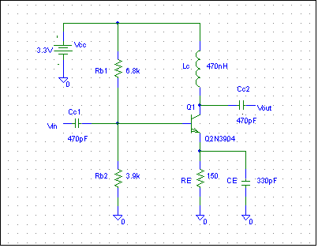
Figure Q1.

Hints: Perform a DC analysis to obtain the transistor bias point. Then use this information to find the small-signal equivalent circuit.

Question 2
Another version of the CE amplifier is shown in Figure Q2, using the NPN transistor 2N2222 (Q1). Find the hybrid-π model of the transistor Q1. Draw the small signal equivalent circuit of the complete circuit. Assume that the following parameters for 2N2222 are given:
h_{FE} = β = 50, h_{fe} = 255, τ = 411.1ps, V_{A}=74.03, C_{jc} = 7.306pF, C_{je} = 22.1pF, r_{b’b} = 10, V_{jc} = 0.75, M=0.3416.

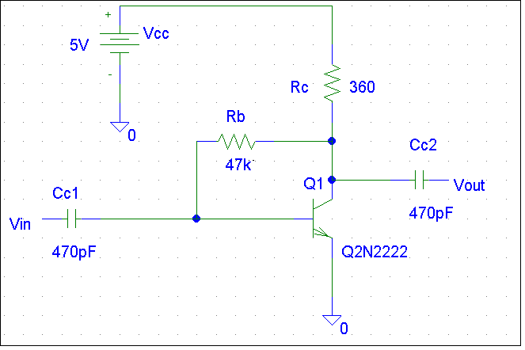
Figure Q2.

