ME1000 RF Circuit Design

Tutorial 2

Transmission Line Circuits and RF Microwave Network Analysis

This courseware product contains scholarly and technical information and is protected by copyright laws and international treaties. No part of this publication may be reproduced by any means, be it transmitted, transcribed, photocopied, stored in a retrieval system, or translated into any language in any form, without the prior written permission of Acehub Vista Sdn. Bhd.

The use of the courseware product and all other products developed and/or distributed by Acehub Vista Sdn. Bhd. are subject to the applicable License Agreement.

For further information, see the Courseware Product License Agreement.

Question 1
A lossless transmission line has per-unit-length L = 473.6 nH, C = 125.0 pF. A 100Ω resistor is connected at the load end of the transmission line. Assume an operating frequency of 2.4 GHz.
- Find the characteristic impedance Z_{c} of the transmission line.
- Find the phase factor β of the transmission line.
- Determine the reflection coefficient Γ_{L} at the load end.
- Determine the reflection coefficient Γ at a distance 2.4 cm from the load.
- Calculate the VSWR along the transmission line.
- Suppose the transmission line is 4.0 cm long, if a matched sinusoidal voltage source of 1.0<0º is connected at the source end, find the complex voltage phasor V_{L} at the load end and the input impedance Z_{in} as seen by the source.
- Calculate the power dissipated by the load.
- What would happen if the source impedance of the voltage source is not match to the transmission line?

Question 2
List the advantages of using S-parameters to describe an N-port network at high frequency.

Question 3
Find the ABCD parameters of the 2-port network below. From the ABCD parameters, determine the network S matrix. Assume Port 1 and Port 2 to be connected to transmission lines with characteristic impedance Z_{c}.
L
C
R
Port 1
Port 2

Question 4
Using the definition of S-parameters, find the S-matrix of the following networks. Consider both ports to be connected to transmission lines with characteristic impedance of Z_{c}.

Y
Port 1
Port 2
Z_{c}
Z_{c}
Z
Port 1
Port 2
Z_{c}
Z_{c}

Question 5 (Exercise on Smith chart)
Assuming a reference impedance of 50Ω, plot the following impedance on a smith chart.
- Z = 50 + j90, Z=50 - j90.
- Z = 1/(50 + j90), Z=1/(50 - j90).
- What can you conclude from the answers to part (a) and (b)?
- Y = 36 - j40, Y = 36 + j40
- Y = 1/(36 - j40), Y = 1/(36 + j40)
- Again what is your conclusion from the answers to part (d) and (e)?

Question 6 (Exercise on Smith chart)
A lossless and homogenous transmission line has Z_{c} = 50Ω and ε_{r} = 4.2 (the dielectric constant is 4.2). Assume an operating frequency of 1.9 GHz. If the transmission line is terminated with a complex load Z_{L} = 80 + j16 at 1.9 GHz, find the input impedance Z_{in} at a distance of 3.0 cm from the load using (a) the Smith chart, (b) the analytical method.

Question 7
Describe the effects of microstrip line discontinuities on the electrical signal propagating along the transmission line.

Question 8
The top view of a printed circuit board (PCB) for an RF amplifier is shown in Figure Q8. The bottom of the PCB consists of a conducting ground plane. Briefly explain the rationale for the following observations:
(i) The use of multiple ‘vias’ to connect the component pins on the top conducting pads to the bottom GND plane.
(ii) The use of ‘flooded’ GND conductors on the top conducting layer.
(iii) The conducting trace connecting the components are kept to minimal length.

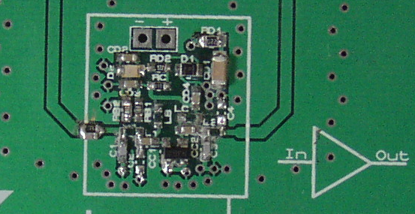
Out
In
RF transistor
Parallel RC
Grounded co-planar line

Figure Q8.

