ME1000 RF Circuit Design

Tutorial2

Transmission Line Circuits and RF Microwave Network Analysis
(Solution)

This courseware product contains scholarly and technical information and is protected by copyright laws and international treaties. No part of this publication may be reproduced by any means, be it transmitted, transcribed, photocopied, stored in a retrieval system, or translated into any language in any form, without the prior written permission of Acehub Vista Sdn. Bhd.

The use of the courseware product and all other products developed and/or distributed by Acehub Vista Sdn. Bhd. are subject to the applicable License Agreement.

For further information, see the Courseware Product License Agreement.

Question 1
A lossless transmission line has per-unit-length L = 473.6 nH, C = 125.0 pF. A 100Ω resistor is connected at the load end of the transmission line. Assume an operating frequency of 2.4 GHz.
- Find the characteristic impedance Z_{c} of the transmission line.
Solution:
L = 473.6 nH, C = 125.0 pF, f = 2.4 GHz
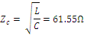

- Find the phase factor β of the transmission line.
Solution:
,

- Determine the reflection coefficient Γ_{L} at the load end.
Solution:
Z_{L} = 100,

- Determine the reflection coefficient Γ at a distance 2.4 cm from the load.
Solution:
Matched Source
+ʓ
Z_{c}, β
Z_{L} = 100
ʓ=0

- Calculate the VSWR along the transmission line.
Solution:
= 1.625

- Suppose the transmission line is 4.0 cm long, if a matched sinusoidal voltage source of 1.0<0º is connected at the source end, find the complex voltage phasor V_{L} at the load end and the input impedance Z_{in} as seen by the source.
ʓ=0
ʓ = -
Solution:
+ʓ
Z_{c}, β
Z_{C}
V_{S}
V_{L}
Z_{L} = 100

At ʓ = 0, V = V_{o}⁺ + V_{o}⁻ = V_{L}
At ʓ = -, V = V_{in}= V_{o}⁺ + V_{o}⁻
Now, we know Z_{in} () = Z_{c} [ ] = 38.008 – j2.729
Z_{S} = Z_{C}
And
V_{in} = V_{S}
V_{L}
Z_{in} ()
= V_{o}⁺ + V_{o}⁻
= V_{o}⁺ (+ )
= V_{o}⁺ (1+ ) , V_{o}⁻ = V_{o}⁺

V_{o}⁺ = 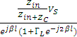 =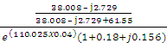
= - 0.036 + j0.5 , Note: for verification, we can show that
|V_{o}⁺| =
Thus, V_{L} = V_{o}⁺ + V_{o}⁻ = V_{o}⁺ (1+ ) = -0.044 + j0.617

- Calculate the power dissipated by the load.
Solution:
Power dissipated by Z_{L}:
P_{L} = = 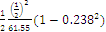
1.92 mW

- What would happen if the source impedance of the voltage source is not match to the transmission line?
Solution: Model Answer Not Available

Question 2
List the advantages of using S-parameters to describe an N-port network at high frequency.
Solution:
S-parameter measurements do not use open/short termination. At RF or microwave frequency, open/short condition is difficult to achieve due to strong inductance and capacitance. S-parameter measurements use matched termination instead, which is repeatable and can be approximated to sufficient accurate degree (VSWR< 1.05) for medium such as transmission line and wave guide. Moreover open/short condition can lead to destructive standing wave, hence not suitable.

Question 3
Find the ABCD parameters of the 2-port network below. From the ABCD parameters, determine the network S matrix. Assume Port 1 and Port 2 to be connected to transmission lines with characteristic impedance Z_{c}.
Solution:

L
C
R
Port 1
Port 2

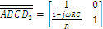

= = 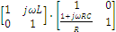 = 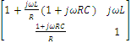

Note: What is shown in the solution for Q3 is just the partial solution. After obtaining the ABCD matrix, you can use the conversion formula in the notes to obtain the S matrix.

Question 4
Using the definition of S-parameters, find the S-matrix of the following networks. Consider both ports to be connected to transmission lines with characteristic impedance of Z_{c}.

Y
Port 1
Port 2
Z_{c}
Z_{c}
Z
Port 1
Port 2
Z_{c}
Z_{c}

Solution:
The solution for the S-parameters for a series impedance is already provided in the lecture slides. Here only the shunt admittance case is discussed.

We first terminate Port 2:
Transmission Line
Z_{c1}
Z_{c2}

Y
Port 1
Port 2

Y₁ = Y’+Y’
Y₁ =

Z_{c1}, Z_{c2} are the characteristic impedance of the transmission line connected to the ports.

= incident voltage at port 1
= incident voltage from port 2 , similar definition applied to port 2.

Z₁ = ==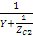=
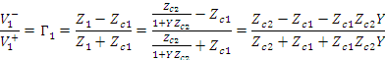
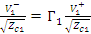
b₁
a₁

From the definition:
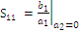 , 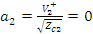since port 2 is terminated.

Similarly we can show that (by interchanging Z_{c1} and Z_{c2}):

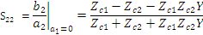

Still terminating port 2:
Z_{c1}
Z_{c2}

Y

Z_{c2}
V₁

V₂

0
Now
Since both ports are shunted together, ;
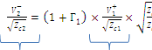
b₂
a₁
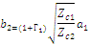
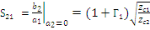 , and expending

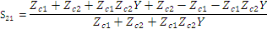
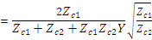
Similarly we can show that:
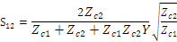

In the special case when$Z_{c1}=Z_{c2}=Z_{c}$, we have:
$s_{\text{11}}=s_{\text{22}}=\frac{−Z_{c}}{2+Z_{c}Y}$ $s_{\text{12}}=s_{\text{21}}=\frac{2}{2+Z_{c}Y}$

Question 5 (Exercise on Smith chart)
Assuming a reference impedance of 50Ω, plot the following impedance on a smith chart.
- Z = 50 + j90, Z=50 - j90.
- Z = 1/(50 + j90), Z=1/(50 - j90).
- What can you conclude from the answers to part (a) and (b)?
- Y = 36 - j40, Y = 36 + j40
- Y = 1/(36 - j40), Y = 1/(36 + j40)
- Again what is your conclusion from the answers to part (d) and (e)?

Solution: Model Answer Not Available

Question 6 (Exercise on Smith chart)
A lossless and homogenous transmission line has Z_{c} = 50Ω and ε_{r} = 4.2 (the dielectric constant is 4.2). Assume an operating frequency of 1.9 GHz. If the transmission line is terminated with a complex load Z_{L} = 80 + j16 at 1.9 GHz, find the input impedance Z_{in} at a distance of 3.0 cm from the load using (a) the Smith chart, (b) the analytical method.

For the Smith Chart approach, use ADS software or other free Smith Chart utilities. For analytical approach:
$$ω=2π\left(1\text{.}9×{\text{10}}^{9}\right),μ_{o}=4π×{\text{10}}^{7},ε_{o}=8\text{.}\text{85412}×{\text{10}}^{−\text{12}}$$
$$β=ω\sqrt{4\text{.}2ε_{o}μ_{o}}=\text{81}\text{.}\text{608}$$
$$Z_{\text{in}}=Z_{c}\left[\frac{Z_{L}+{\text{jZ}}_{c}\text{tan}\left(βl\right)}{Z_{c}+{\text{jZ}}_{L}\text{tan}\left(βl\right)}\right]=\text{40}\text{.}\text{128}+j\text{21}\text{.}\text{963}$$

Question 7
Describe the effects of microstrip line discontinuities on the electrical signal propagating along the transmission line.

The discontinuities have the effect of filtering high-frequency components of the signal. All practical interconnections are band limited by nature. Most discontinuities have equivalent circuits which resemble low-pass filter. The LC elements in the equivalent circuits are attributed to the localized (or evanescent) higher-order EM fields induced by the discontinuitites. In addition, at very high frequencies, the higher-order (e.g. non quasi-TEM) EM field induced at the discontinuities will no longer be localized. This is because higher-order mode EM fields such as TM or TE modes have cut-off frequency. Below this frequency the fields are evanescent or localized, beyond the cut-off frequency the fields start to propagate, usually in the form of surface waves. Thus at very high frequencies, typically above 10 GHz for dielectric thickness of 0.5 mm and above, discontinuities can actually cause spurious radiation.

Question 8
The top view of a printed circuit board (PCB) for an RF amplifier is shown in Figure Q8. The bottom of the PCB consists of a conducting ground plane. Briefly explain the rationale for the following observations:
(i) The use of multiple ‘vias’ to connect the component pins on the top conducting pads to the bottom GND plane.
(ii) The use of ‘flooded’ GND conductors on the top conducting layer.
(iii) The conducting trace connecting the components are kept to minimal length.

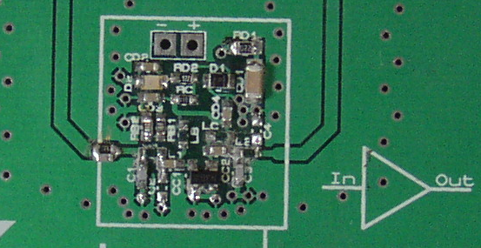
Out
In
RF transistor
Parallel RC
Grounded co-planar line

Figure Q8.
Solution: Model Answer Not Available

