ME1000 RF Circuit Design

Tutorial 10

Large-Signal
Circuits and RF Oscillators

This courseware product contains scholarly and technical information and is protected by copyright laws and international treaties. No part of this publication may be reproduced by any means, be it transmitted, transcribed, photocopied, stored in a retrieval system, or translated into any language in any form, without the prior written permission of Acehub Vista Sdn. Bhd.

The use of the courseware product and all other products developed and/or distributed by Acehub Vista Sdn. Bhd. are subject to the applicable License Agreement.

For further information, see the Courseware Product License Agreement.

Question 1
Base on the data from Example 4.1 in Chapter 10, design a fix frequency oscillator at 410Mhz. However this time use the rule:
$\begin{aligned}R_{s}=\frac{1}{5}\left|R_{1}\right| \\ X_{s}=−\left|X_{1}\right|\end{aligned}$

After completing the circuit design, run a transient simulation on the schematic and analyze the amount of harmonic distortion observed on the output waveform.

Question 2
(a) An emitter-degenerate common-emitter amplifier with feedback (Figure Q2) is used to build a fix frequency oscillator at 430MHz. Find the DC collector current I_{C} and V_{CE} of transistor Q₁.
(b) The simulated S-parameters of this circuit are:
S₁₁ = 2.634<-75.012º
S₂₁ = 3.597<152.356º
S₁₂ = 0.294<39.818º
S₂₂ = 0.978<-20.985º
Z_{o} = 50Ω

Complete the oscillator design by finding suitable network to be connected to Port 1, assume a 50Ω load impedance is connected to Port 2.

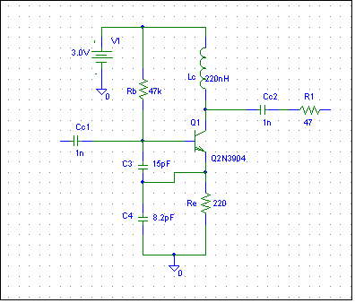
Port 1
Port 2
BFR92A
Figure Q2.
(c) Elaborate on the main function of inductor L_{c}.
(d) Briefly explain why it is important to keep the power supply (V_{CC}) to an oscillator as stable as possible.

Question 3
(a) Show that the 3rd order term in the power-series expansion model of a large-signal amplifier
result in signal components that increase with a rate of 3 times the input power level in dBm.

(b) The following diagram is captured on a spectrum analyzer of a Power Amplifier (PA) operating at
5 GHz. The two signal frequency are spaced 1 MHz apart. Determine the Intermodulation
Distortion and the Third Order Intercept point power levels. Also estimate the 1dB Gain
Compression power for this PA. NOTE: The vertical scale is 10dB/division.
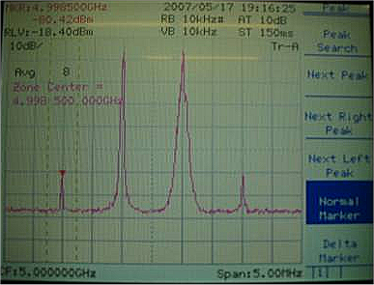

Question 4
An amplifier has the following power series expansion coefficients at 900 MHz with 50Ω source and load impedance:

α₁=12, α₂=1.5 and α₃=-0.67. These coefficients are obtained by performing some measurement and employing statistical method. If one were to use this amplifier to construct a down-conversion mixer, with 900 MHz RF input and 850 MHz LO input, find the conversion gain of this mixer in dB.

Question 5
Suppose you have 3 amplifiers A, B and C with properties as shown in the table below. The amplifiers are cascaded together as shown in Figure Q5. Determine the maximum output power available from the cascaded amplifiers. Assume the amplifiers input and output are matched to each other and the system impedance is 50Ω.

Amplifier Module | V_{cc}/V | I_{cc}/mA | Small-signal power gain (with 50Ω source and load impedance) | 1 dB Gain Compression Output Power
A | 5.0 | 20.0 | 10.0 | +10.0 dBm
B | 5.0 | 25.0 | 12.0 | +16.0 dBm
C | 5.0 | 30.0 | 10.0 | +24.0 dBm

A
B
C
A

Cascaded Amplifier 1.

Cascaded Amplifier 2.

Figure Q5.

