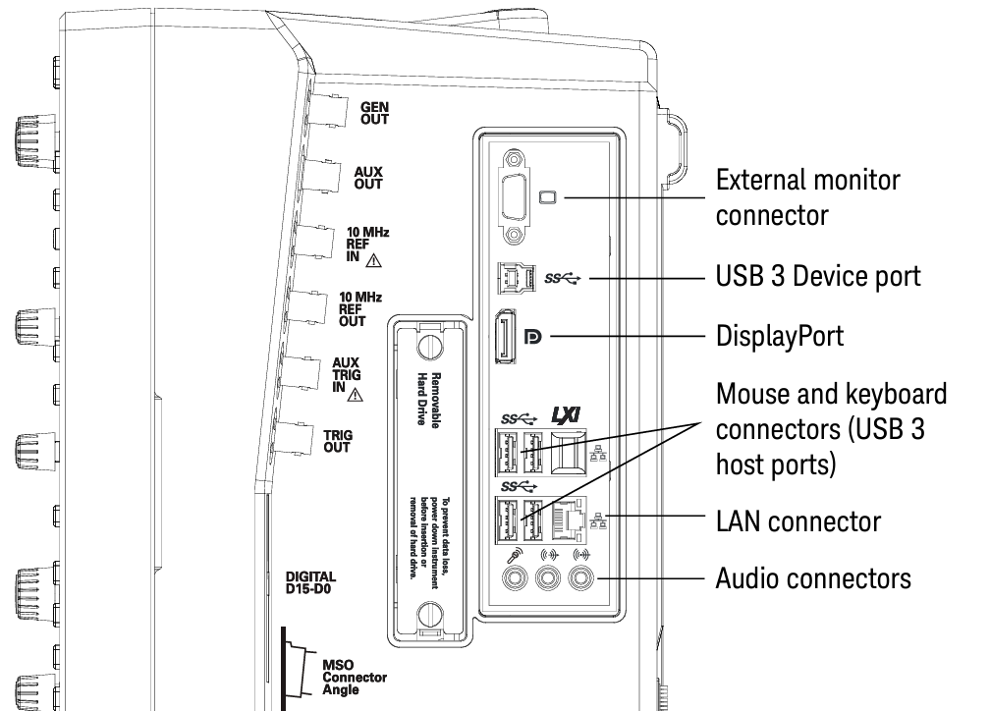

**MXR Side panel I/O**

GEN OUT Built-in AWG output.

AUX OUT Use the “Calibration Output” dialog box to select between:  
 DC level, probe compensation signal, trigger out signal, demo signal

10 MHZ REF IN To synchronize horizontal time base to an external reference clock  
 10MHz, +/- 20ppm  
 Amplitude (sinewave) 356mVpp (-5dBm) min to 5Vpp (+18 dBm) max  
 Amplitude (square) 285 mVpp min to 4 Vpp max  
 Input impedance 50 ohm

10MHZ REF OUT To send the internal 10MHz REF clock to another instrument 10MHz REF IN   
 Amplitude into 50 ohm: 1.65 +/- 0.05 Vpp (8.3+/- 0,3 dBm) sinewave  
 If internal time base selected: 10MHz +/- (8ppb + 75 ppb/year)  
 If external time base selected: specs of 10MHz REF IN

AUX TRIG IN To trigger the scope   
 Max voltage: 5Vpp max between -5V and +5V, on 50 ohm.

TRIG OUT TTL levels into high impedance

DIGITAL D15-D0 Use MSO cable provided for 16 digital input channels, 8 GS/s, 400MHz

**PROBE INPUTS**

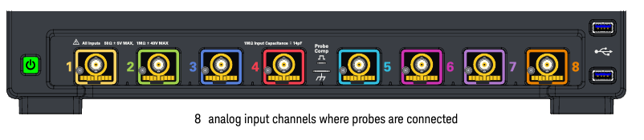

**Do not exceed the maximum input voltage rating.**

**When measuring voltages over 30 V, use a 10:1 probe.**

50 Ω input impedance : The maximum input voltage is ±5 V.

1 MΩ input impedance: The maximum input voltage is 30 Vrms or ±40 Vmax (DC+Vpeak).

Passive Probe 10:1 500MHz

**N7026A AC/DC High-Sensitivity Current Probe, 150 MHz, 1 mA/div, Clamp On**

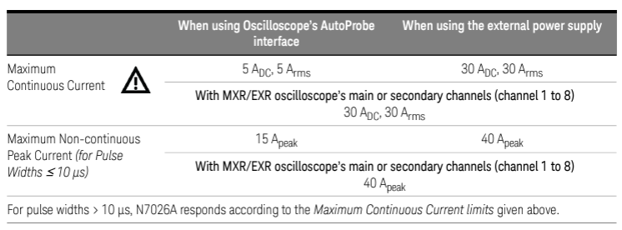

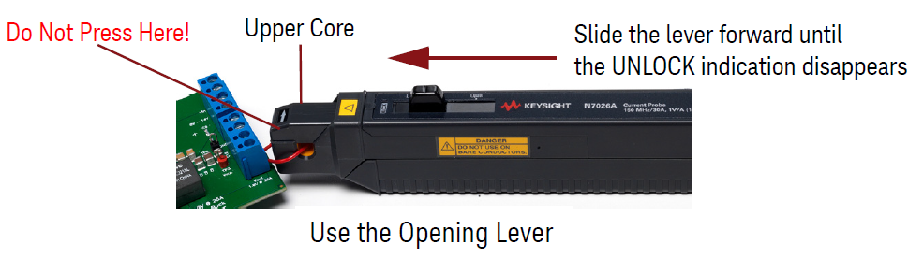

DP0012A-FG Differential Active Probes, 1 GHz, 42 V, 1.7 Mohm 1.5 pF